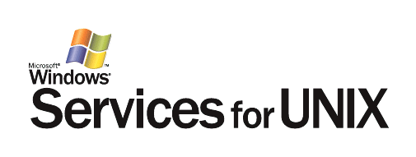
Microsoft® Windows® Services for UNIX 3.5

Reviewer’s Guide
January 15, 2004



The information contained in this document represents the current view of Microsoft Corporation on the issues discussed as of the date of publication. Because Microsoft must respond to changing market conditions, it should not be interpreted to be a commitment on the part of Microsoft, and Microsoft cannot guarantee the accuracy of any information presented after the date of publication.
This document is for informational purposes only. MICROSOFT MAKES NO WARRANTIES, EXPRESS OR IMPLIED, AS TO THE INFORMATION IN THIS DOCUMENT.
Complying with all applicable copyright laws is the responsibility of the user. Without limiting the rights under copyright, no part of this document may be reproduced, stored in or introduced into a retrieval system, or transmitted in any form or by any means (electronic, mechanical, photocopying, recording, or otherwise), or for any purpose, without the express written permission of Microsoft Corporation.
Microsoft may have patents, patent applications, trademarks, copyrights, or other intellectual property rights covering subject matter in this document. Except as expressly provided in any written license agreement from Microsoft, the furnishing of this document does not give you any license to these patents, trademarks, copyrights, or other intellectual property.
© 2004 Microsoft Corporation. All rights reserved.
Microsoft, Windows, Active Director, Windows Server and Win32 are either registered trademarks or trademarks of Microsoft Corporation in the United States and/or other countries.
The names of actual companies and products mentioned herein may be the trademarks of their respective owners.

About this guide 1

Contents
Audience 1
Document Overview 1
Legend and Notation 1
What is Microsoft Windows Services for Unix? 2
computing Environment 3
Advantages of SFU 4
Interoperation 4
Integration 5
Extensibility 6
Features of sfu 3.5 7
new in sfu 3.5 8
installation walk-through 10
Prerequisites and Assumptions 10
Recommended Test Setup 10
Installation 11
Upgrading to SFU 3.5 15
shells and utilities walk-through 16
Shells and Utilities 16
Introduction to Shells 17
Differences Between UNIX and Win32 19
UNIX Commands 20
Sample Usage of UNIX Utilities 20
Regular Expressions and Pattern Matching 25
File Editing 25
Typical Use of UNIX Utilities 27
Help System 27
unix daemons 29
cron Scheduler 29
syslogd 30
inetd 32
sendmail 33
dns 33
calling Win32 applications from interix 34
administration in the win32 environment 35
interix systems security 36
Root/Superuser Privileges 36
windows object security 38
Directory Security 38
domains and user names 41
Script porting 42
Shell Scripts 42
Perl Scripts 43
Development and debugging tools 47
porting applications 49
Tools and Utilities 49
Programming 49
X Windows 49
Curses 50
Symbolic Links 50
Principles of Porting the Code 51
user name mapping 55
Configuring the User Name Mapping Service 55
Migration of NIS to Active Directory 58
configuring nfs 60
Server for NFS 60
Client for NFS 60
Configuration of NFS Client-Server Environment in Windows 61
Configuration of NFS Client-Server Environment in UNIX 64
NFS Mapping Between Windows and UNIX 67
configuring password synchronization 70
On the Windows side: 70
On UNIX side (RedHat 8.0 was taken as an example): 72
conclusion 74
appendix A 75
appendix B 76
appendix c 77

Figure 1. SFU 3.5 installation. Welcome screen. 11

figures
Figure 2. SFU 3.5 installation. Customer information screen. 11
Figure 3. SFU 3.5 installation. License and support information. 12
Figure 5a. SFU 3.5 installation. Standard installation options. 12
Figure 5b. SFU 3.5 installation. Custom installation options. 13
Figure 4. SFU 3.5 installation. Interix GNU SDK LGPL information. 13
Figure 6. cal utility. 20
Figure 7. cal utility. Calendar for the entire year. 21
Figure 8. cat utility. 21
Figure 9. sort utility. 22
Figure 10. head and tail utilities. 22
Figure 11. ps utility. 23
Figure 12. find and grep utilities. 24
Figure 13. df utility. 24
Figure 14. Line editing with tr utility. 26
Figure 15. File line editing with sed utility. 27
Figure 16. Listing of cron autoloader. 29
Figure 17. Execution of allfile script. 43
Figure 18. Testing results of execution of allfile script. 43
Figure 19. Testing the functionality of syslog by analyzing syslogentries. 44
Figure 20. Compilation of log_analysis script. 45
Figure 21. Execution of log_analysis script. 45
Figure 22. User Name Mapping between UNIX and Windows hosts. Listing users. 56
Figure 23. User Name Mapping between UNIX and Windows hosts. Mapping users with non-matching names. 57
Figure 24. User Name Mapping between UNIX and Windows hosts. Mapping user groups. 57
Figure 25. NFS folder sharing in Windows. 61
Figure 26. Checking permissions in NFS folder sharing in Windows. 62
Figure 27. Mapping shared NFS drive in Windows. 62
Figure 28. Mapping shared NFS drive in Windows. 63
Figure 29. System prompt during NFS mapping process. 63
Figure 30. Testing access to the data on the mapped NFS drive. 64
Figure 31. Creation of a directory in UNIX and creation of a file in the directory. 65
Figure 32. Starting NFS services on UNIX. 65
Figure 33. Testing that NFS services are running. 66
Figure 34. Mapping NFS share from UNIX and testing file access in the mapped share. 66
Figure 35. Mapping UNIX NFS share from Windows. 67
Figure 36. System prompt during NFS mapping process. 67
Figure 37. Listing the content of the mapped NFS share. 68
Figure 38. Checking the integrity of the file on the mapped NFS share. 68
Figure 39. Mapping Windows NFS share from UNIX and testing its content. 69
Figure 40. Configuration of password synchronization services. 71
Figure 41. Configuration of targets and ports in password synchronization services. 71

This Reviewer’s Guide provides a detailed technical description of Microsoft® Windows® Services for UNIX 3.5 (SFU) and specific examples of its use. The guide demonstrates key benefits of the product and clarifies how SFU enables interoperability strategies for existing heterogeneous network and application development environments comprised of both Windows and UNIX technologies.

About this guide

Audience
This guide is intended for those who wish to evaluate the Microsoft Windows Services for UNIX solution, particularly as they are interested in computing-platform interoperability solutions.
Those who are new to SFU and seek a comprehensive understanding of the capabilities of this product are encouraged to read this document in its entirety. Those familiar with previous versions of the product can search out relevant information below concerning additions and improvements found in Microsoft Windows Services for UNIX 3.5 pertinent to their interests.

Document Overview
This guide begins with a brief introduction to Microsoft Services for UNIX (SFU) followed by a discussion of the need for interoperability in heterogeneous computing environments and a review of the kinds solutions available in the Windows and UNIX interoperability arena. The remainder of the document focuses on the functionality of the product and examples of its use for the purposes of interoperability, overall system management, and application development and deployment. The appendix details the changes between SFU 3.5 and previous versions.

Legend and Notation
The practical nature of this guide calls for a number of exercises involving commands entered both on UNIX and Windows platforms. These commands are set apart with quotation marks and appear in bold italics (e.g., “ls –laRt”). The corresponding system responses are displayed on the subsequent screen graphic. Certain commands and systems responses may differ depending on the version of UNIX employed by the user.
Microsoft Windows Services for UNIX 3.5 is an interoperability toolkit designed to streamline interaction between the Windows Server™ 2003 Family, Windows XP Professional and the Windows 2000 Family of operating systems and UNIX or Linux systems in heterogeneous networks. The SFU toolset enables businesses to build solutions to manage the interoperation of both Windows and UNIX computing assets across the enterprise. By providing interoperability tools and protocol support to unify these systems, SFU makes the achievement of this goal as simple and straightforward as possible.

What is Microsoft Windows Services for Unix?
Since its introduction in 1999, SFU has filled a key position by allowing heterogeneous networks consisting of Windows and UNIX systems to functionally coexist. Each version of SFU has extended and substantially improved the tools and bi-directional integration of the solution and improved functional performance.
With the release of version 3.0 in May 2002, Microsoft replaced the utility and shell emulation layer of previous versions with Interix technology. Interix is a full application execution subsystem running beside the Win32® subsystem that lets you compile and natively run UNIX programs and scripts on Windows operating systems.
With SFU 3.5, Microsoft has again extended the functionality as well as the performance of the product. NFS support has been extended to include native support for Windows Server 2003 Active Directory® and performance has improved substantially for Server for NFS and Server for NIS components. Additionally, the Interix SDK now includes support for threaded applications and updated utilities and APIs. Across the board, performance is increased for all aspects of the Interix subsystem with some portions performing nearly on par with corresponding Win32 subsystems.
Businesses of all kinds have come to rely, more and more, on their computing infrastructures. They have also become accustomed to finding the solution that makes the most sense. Hence, there are many heterogeneous environments in production comprised of both Windows and UNIX systems. Making sure that these systems work together every day and through any changes while keeping skilled employees, whether IT personnel or knowledge workers, productive in their environments is a top priority when improving the network to better meet business requirements.

computing Environment
The need for interoperability between Windows and UNIX is evident in these heterogeneous environments. The obvious time savings and therefore monetary savings involved in having a smoothly integrated environment is a boon to business. And so Microsoft Windows Services for UNIX 3.5 provides the functionality necessary to:
- Manage and authenticate users across Windows and UNIX platforms
- Share resources across multiple operating systems in both directions, with proper handling of user privileges
- Monitor and administer Windows and UNIX systems in the same fashion and with the same tools
- Seamlessly transfer applications to Windows environments, including those with calls to UNIX-specific systems, networks, and APIs
- Run UNIX applications from Windows hosts
- Deliver a familiar system experience to UNIX application developers
- Establish a single source code baseline and uniform management utilities and procedures across the enterprise
In short, Microsoft Windows Services for UNIX 3.5 provides the operational interoperability necessary to weave together a fully integrated, heterogeneous network. Further, it accomplishes this coexistence while building on the expert and experienced skill sets of those who use the network on a daily basis.

When attempting to implement a coexistence strategy for a heterogeneous environment consisting of Windows and UNIX systems, architects and administrators have few options: They can implement interoperability tools on the UNIX side, collect and compile UNIX utilities for their Windows operating systems, operate multiple third-party products for an essentially custom solution, or implement the Microsoft Windows Services for UNIX 3.5 solution.

Advantages of SFU
When compared with the alternatives, the advantages of the SFU solution become apparent. In trying to collect and deploy interoperability tools on the UNIX side, it becomes readily apparent that these tools are few and limited to bi-directional file systems access between platforms. While it is possible to obtain the source code for almost every UNIX utility, tremendous development effort is required to port every utility (often including rewriting parts of the applications with the calls to Windows-specific API sets instead of UNIX-specific APIs), test the functionality of each, and ascertain the compatibility of the utility with different OS updates. Alternately, it is possible to create the desired solution from a combination of commercially available packages. The problem with this approach is the incompleteness of tools offered by different vendors. Some vendors offer cross-platform file and password interoperability, while others offer administrative tools, command line utilities, and system call libraries/APIs for application migration and development projects. In order to create a comprehensive solution similar in scope to SFU, multiple products from multiple vendors must be independently purchased, implemented and integrated in a single environment.
Microsoft Windows Services for UNIX 3.5 provides a single, well integrated solution from one vendor. The SFU solution provides a single platform for Interoperation, Integration and Extensibility (each of these will be looked at shortly) with the integral benefits of such a solution. By implementing a unified solution many potential incompatibilities between differing areas of the implementation are eliminated since SFU has been designed and tested as an holistic solution. Further, SFU is a single license, reducing the administrative burden of managing, and financial burden of purchasing, multiple licenses for different products used in different areas of the computing infrastructure. (Windows Services for Unix 3.5 is downloadable at no cost.) Microsoft provides a single source of support for the product, minimizing the need to open and manage service tickets among several vendors where there is a multi-product custom interoperability solution. Additionally, having a solution from a long-standing company helps ensure ongoing product viability and support in the years to come.

Interoperation
Services for UNIX 3.5 provides a full range of cross-platform services designed to allow easy and straightforward interoperability between Windows and UNIX-based systems. SFU provides services that enable single sign-on, bi-directional file and print accessibility and a single point of administration so that you can optimize your existing infrastructure investments.
SFU 3.5 provides the tools to share access to Network File System (NFS) resources hosted on either the Windows or UNIX platforms without changing the ways in which users normally go about connecting to those resources. Client for NFS allows Windows-based machines on which it is installed to access NFS resources anywhere on the network without additional software installed on the UNIX servers hosting those resources. With Gateway for NFS installed, a Windows server provides access to NFS resources for other Windows-based clients that have no SFU components installed on them. Server for NFS allows the Windows machine on which it is installed to provide file system resources to any NFS clients on the network.
Resource sharing becomes even easier when you link user accounts on disparate systems and synchronize password changes for those accounts. The User Name Mapping service in SFU provides one-to-one and many-to-one mapping of Windows users and groups to UNIX user and group identities and vice versa. User Name Mapping can be deployed on a single machine in the organization and all NFS components in the network can access this server for mapping to maintain consistent NFS access from all computers. When coupled with two-way password synchronization, Windows local and domain accounts are kept up-to-date with corresponding UNIX accounts and vice versa. Password synchronization can be implemented bi-directionally so that changes to either Windows or UNIX passwords will propagate to the other systems. Users need only remember a single system password for accounts in a heterogeneous network and the administration of password changes is simplified and secured for administrators who can work from a single machine while maintaining the flexibility of control over the users and systems for which such synchronization takes place. Additionally, with Server for NIS, a Windows domain controller can be used as a master NIS server to administer a UNIX NIS domain.

Integration
Microsoft Windows Services for UNIX 3.5 makes the Windows platform more approachable for UNIX IT professionals by allowing them to use the UNIX-based tools and utilities with which they are familiar on the Windows platform. Because they have access to familiar tools and utilities, they can easily perform their normal tasks the way they always have; and they can also perform those tasks cross platform, remotely or locally monitoring and administering Windows and UNIX-based systems in the same way.
Both C Shell and Korn Shell are available in SFU, and both behave exactly as they do in UNIX environments. C Shell provides the same advantages as in UNIX, namely, support for both aliases and command history including simple command scrolling using arrow keys. In Interix, the Korn Shell has many features in common with C shell (history, vi and emacs key bindings), but is much closer to the Bourne shell in syntax. Because of the SFU architecture, many scripts written for these shells in the UNIX environment migrate without modification.
SFU includes more than 350 UNIX utilities as well as a full port of Perl 5.6.1 and Perl Script to ease administrative and user transition. With its single rooted file system, SFU provides an environment that is very similar to the native UNIX environment. Additionally, it includes its own Interix-based Telnet server and client (as well as the Windows Telnet server and client) to provide broad terminal support for remote access to both UNIX and Windows command consoles.

Extensibility
Services for UNIX 3.5 enables you to easily extend the value of existing UNIX applications by running them side by side with Windows and Microsoft .NET-enabled applications on a single, easily managed and familiar platform. SFU allows you to port applications quickly and access them with their traditional interfaces; furthermore, you can easily add COM interfaces to these applications and even expose their functionality through Web services.
The release of Services for UNIX 3.0 and, subsequently, the release of Services for UNIX 3.5, have seen the replacement of the MKS-derived Korn Shell and utilities with the Interix environment and the Interix SDK. The Interix environment is a fully integrated, high performance, POSIX-compliant UNIX environment with a full SDK and subsystem that runs natively under supported Windows operating systems. It is the Interix environment that provides complete support for compiling and running UNIX applications on Windows.
The Interix environment in SFU 3.5 provides UNIX developers with a UNIX execution environment that includes full support for more than 2,000 UNIX APIs and over 350 UNIX utilities. Further, scripts written to run under UNIX transfer to Interix easily and naturally. These give UNIX developers and administrators the broadest, most familiar, and most compatible scripting environment possible. Utilities include awk, grep, sed, tr, cut, tar, cpio, and a host of others, all of which work exactly as the UNIX administrator or programmer expects. Plus, with a single rooted file system, utilities and configuration files are in the standard UNIX locations.
Microsoft Windows Services for UNIX 3.5 adds a rich set of features to the Windows Server 2003 Family, Windows XP Professional, and the Windows 2000 Family, enabling seamless interoperability with UNIX-based in heterogeneous environments.

Features of sfu 3.5
SFU 3.5 provides the following tools to implement interoperation, integration and extensibility within any Windows/UNIX environment:
- NFS Client, Server, Gateway, and Server for PCNFS – allow authorized users to exchange files between Windows and UNIX platforms.
- User Name Mapping – is a service that allows users to connect to NFS resources without having to log on to UNIX and Windows systems separately.
- NIS Server – enables a Microsoft Windows-based Active Directory domain controller to administer UNIX Network Information Service (NIS) networks.
- Password Synchronization – allows users to maintain one password across the operating environments and have it synchronized between the systems.
- Base Utilities –include common Windows utilities, UNIX command line utilities, X-Windows utilities, X11R5 & X11R6 window managers, terminal emulators, graphic programs, cron, etc.
- Telnet server and a telnet client – provide remote access and administration.
- Administrative tools – provided with graphical and command line interfaces to manage each of the SFU services.
- Interix – is a UNIX-compatible (POSIX-compliant) subsystem that allows developers to compile and natively run UNIX programs and scripts on Windows. Interix features a full set of typical UNIX utilities, a Perl interpreter, typical network daemons, and C and Korn Shells.
- Interix SDK – includes all of the standard UNIX development environment tools and utilities such as make, rcs, lex, yacc, and cc. The development environment comes with the full set of system libraries and X11 libraries.
For a complete list of Windows Services for UNIX 3.5 features and a comparison to previous versions, see the Table in the Appendix.
Microsoft Windows Services for UNIX 3.5 adds new features and improves the functionality and performance of SFU through enhancements to existing elements of the product.

new in sfu 3.5
The improvements in SFU 3.5 provide enhanced Interoperation, Integration and Extensibility.
Interoperation improvements include:
- Tighter Active-Directory integration – NFS support has been extended to improve authentication in native Windows Server 2003 Active Directory environments.
- System scalability – Additional improvements in multiprocessor scalability have also been realized, resulting in a roughly 50% improvement in performance with Interix on an 8-way system.
- NFS performance – There have been substantial performance improvements (over 50% performance increase) in the Server for NFS and Server for NIS components of SFU.
- Other – In addition to the performance enhancements for Server for NFS, Microsoft has improved the administration and functionality by providing support for setuid/setgid/sticky bits, improved translation of Windows file permissions, per-share properties, and support for International encoding in filename translation.
Integration improvements include:
- Administration – There have been a number of changes to the SFU administrative interface to improve both the command line and the GUI administration, including support for clustering (GUI only), additional character sets, filename character translation, per-share configuration settings, and wildcards in the last octet of the IP address for NFS client groups administration. The collective impact of these changes significantly improves the overall ease and effectiveness of administration.
- Windows Server 2003 support – SFU 3.5 supports new Windows Server 2003 features such as Volume Shadow Copy. With Server for NFS, point-in-time copies of shared files and folders enables easy, reliable off-line backup and simple recovery of those files. When run in a native Windows Server 2003 Active Directory context, Server for NFS uses Protocol Transition to authenticate domain users, eliminating the need for installing the Server for NFS Authentication component on all domain controllers.
- Cluster aware – The User Name Mapping Server and NFS Service are now fully cluster-aware for easy cluster configuration. Additionally, existing NFS shares can be upgraded and clustered for greater availability and NFS shares are supported on active-active clusters for greater hardware utilization.
- Dynamic registry – Many changes to performance-related registry keys are dynamically recognized. With this enhancement, network administrators can easily try out many kinds of changes without having to reboot, making performance tuning under real-world conditions practical.
Extensibility improvements include:
- Pthread support – Microsoft has extended the Interix SDK to support threaded applications.
- Subsystem throughput – The Interix subsystem shows improvements in all aspects of Interix performance ranging from 30% improvements in fork and exec performance, to 75% in pipe bandwidth, to more than 150% in fstat latency.
- Disk read/write performance – Interix file I/O performance has increased more than 100% and is now within 10% of the Win32 subsystem.

Prerequisites and Assumptions

installation walk-through
The reviewer is expected to have basic familiarity with Windows and UNIX operating environments and to understand client-server interaction in a networked environment.

Recommended Test Setup
This section describes the product and peripheral configurations that best demonstrate the product, which should be used in order to perform the hands-on exercises that follow. Minimum configuration and requirements will also be noted if these significantly differ from the recommended test setup.
Windows Services for UNIX 3.5 runs on Windows Server 2003, Windows XP Professional, and Windows 2000 (Professional and Server). For the purpose of this walkthrough, we recommend installing Microsoft SFU 3.5 on Windows Server 2003. The hardware and software configuration of the computer can be obtained by running winmsd from command line.
The minimum recommended hardware requirement for Microsoft Services for UNIX 3.5 is the following:
- Intel Pentium III or AMD Athlon system with a clock speed of 500 MHz or faster
- Minimum of 256 MB RAM
- 30 MB available hard disk space
- At least one Ethernet or Fast Ethernet adapter with bound TCP/IP protocol

Windows Services for UNIX 3.5 has been designed to work with a broad range of UNIX varieties and has been explicitly tested for interoperability with Solaris 2.7 and 2.8, HP-UX 11i, AIX 5L5.2, as well as Red Hat Linux 8.0. Any combination of supported hardware and software on the UNIX side is possible; however, a standard combination such as Solaris 8 on Sun Ultra 5 or Red Hat 8.0 on a generic PC is recommended. The UNIX environment should run the following services:
- telnetd (and/or sshd)
- NFS services (nfs and nfslock)
- NIS services (ypbind, yppasswdd, ypserv, and ypxfrd)

Installation
Microsoft Services for UNIX 3.5 comes as a Windows Installer Package (MSI).
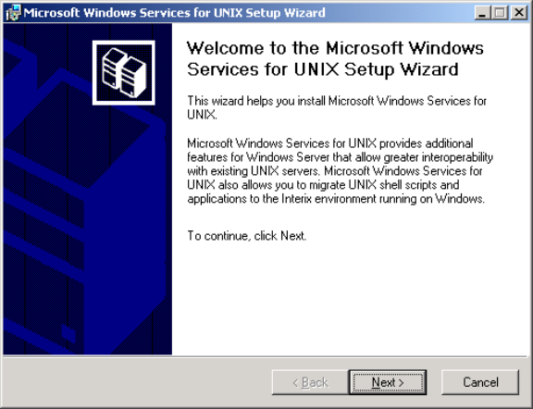
The installation is simple and straightforward and takes approximately twenty minutes for the full installation (or less for partial installation) on a Windows computer.

Figure 1. SFU 3.5 installation. Welcome screen.
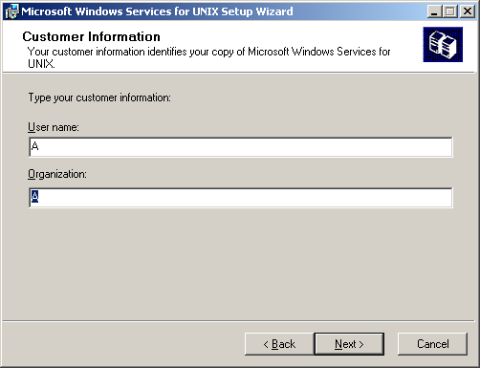

Figure 2. SFU 3.5 installation. Customer information screen.
The user is required to accept the Microsoft license agreement.
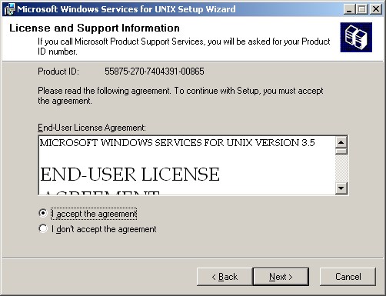

Figure 3. SFU 3.5 installation. License and support information.
Default and custom installations are offered. In most instances, system administrators installing SFU will choose to perform a custom installation so they may properly configure SFU for their environments.
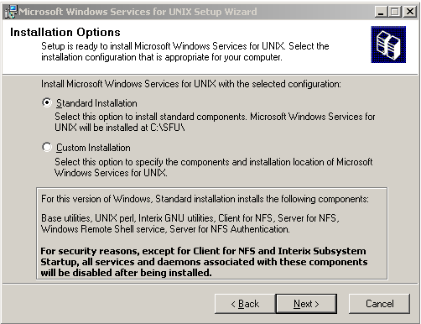

Figure 5a. SFU 3.5 installation. Standard installation options.
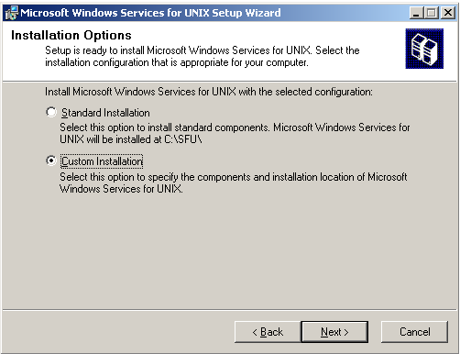
During a custom installation of certain components, the user is informed of LGPL and Active State license agreements when installing Interix GNU SDK.

Figure 5b. SFU 3.5 installation. Custom installation options.
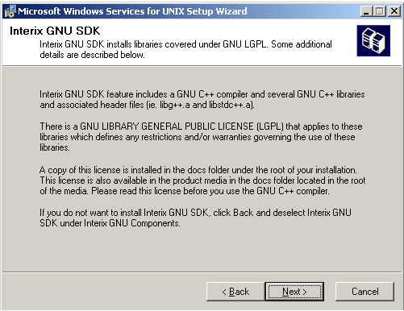

Figure 4. SFU 3.5 installation. Interix GNU SDK LGPL information.
The following table shows the components that are installed by default (Standard Installation) and the components that are available as part of a customized installation (Custom Installation). If you opt to perform a customized installation, you can either choose to add components not installed by default or you can choose not to install components that are automatically installed as part of the standard installation. The designation "N/A" indicates that the component is not available on the specified operating system.

Component | Windows 2000 Professional, or Windows XP Professional | Windows 2000 Server or Windows Server 2003, except domain controllers | Windows 2000 Server or Windows Server 2003 domain controllers
Base utilities, including Interix subsystem | Standard | Standard | Standard
UNIX Perl | Standard | Standard | Standard
Interix GNU utilities | Standard | Standard | Standard
Interix GNU SDK | Custom | Custom | Custom
Client for NFS | Standard | Standard | Standard
Server for NFS | Custom | Standard | Standard
Gateway for NFS | N/A | Custom | Custom
Server for NIS | N/A | N/A | Standard
Password synchronization | Custom | Custom | Standard
Telnet Server (available Windows 2000 only) | Standard | Standard | Standard
Windows-based Remote Shell and Cron services | Custom | Standard | Standard
User Name Mapping | Custom | Custom | Standard
Server for NFS Authentication | Custom | Standard | Standard
Server for PCNFS | Custom | Custom | Custom
Interix SDK | Custom | Custom | Custom
ActiveState Perl | Custom | Custom | Custom
NFS authentication uses either Windows domain accounts or local accounts on the Windows server. Server for NFS Authentication must be installed on all domain controllers in the domain if NFS users will be authenticated using domain accounts. Server for NFS authentication is always installed on the computer running Server for NFS.
Although you cannot install Windows SFU Telnet Server on a computer running Windows XP or Windows Server 2003, you can use SFU Administration to manage the Telnet server that is included with Windows.
For the sake of clarity, these are the features not installed in the default installation:
- Interix SDK
- Password synchronization
- Username mapping
- Gateway for NFS
- Server for PCNFS
- GNU SDK (includes gcc, gdb, etc.)
- Active State Perl
NIS only installs on Windows 2000 domain controllers and .Windows Server 2003 domain controllers.
In the case of a full installation the user is prompted to choose to install NFS Client or NFS Gateway. The installation process may require the user to reboot the system upon successful installation.

Upgrading to SFU 3.5
If you are upgrading from Windows Services for UNIX version 3.0, all installed components will be upgraded. Users of SFU versions 2.0 and 2.2 will need to perform a clean installation of SFU 3.5.
As of SFU 3.0, SFU includes the Interix subsystem rather than an emulation layer. This enhancement imparts significant performance improvements to the product and also creates an execution environment that simplifies the process of porting UNIX applications to be hosted on Windows. The Interix subsystem includes both Korn and C Shell environments, over 350 UNIX utilities, and Perl 5.6.1. These tools give UNIX developers and administrators a standard UNIX scripting environment to administer and develop against. The utilities that ship with SFU 3.5 include awk, grep, sed, tr, cut, tar, cpio, and a host of others, all of which work exactly as the UNIX administrator or programmer expects. Plus, with a single rooted filesystem, utilities and configuration files as of 3.5 are located in the standard UNIX locations where system administrators and developers would expect to find them.

shells and utilities walk-through

Shells and Utilities
The Korn and C Shell implementations that are available in the Interix subsystem behave exactly as they do in a UNIX environment yet, unlike the MKS style Korn Shell provided prior to Windows Services for UNIX 3.0, both shells use a single rooted file system you no longer need to convert scripts to support DOS-based drive letter syntax. For example, in previous versions of SFU, the fully qualified path to a user’s build.ksh script in their personal bin directory would be:
U:/bin/build.ksh
while a script that needed to parse the hosts file might have been looking at:
C:/Windows/system32/drivers/etc/hosts
In SFU 3.5, using the Interix subsystem, that build script would be located at:
/dev/fs/U/bin/build.ksh
while the hosts file would be exactly where you would expect it to be:
/etc/hosts
This simple change makes it much easier to migrate scripts from UNIX to Windows for two important reasons. Not only is there a single rooted file system, as per the UNIX standard, but also the colon character retains its normal UNIX meaning as a field separator in PATH variables, etc.
Another major difference from earlier versions of SFU is that the special profile files that Interix reads to control the shells’ behavior are the same names under Interix as they are in UNIX. This makes it easy for users to maintain a single .profile and .kshrc (or .login and .environ for C shell users) across multiple environments, and it even allows users to use Client for NFS to make their home directory reside on an NFS shared directory across a mixed Windows and UNIX network.
For UNIX system administrators and Linux users who are more comfortable with either tcsh or the bash shell, current versions of tcsh and bash compiled for SFU are available from the Interop Systems Tools Warehouse (http://www.interopsystems.com/tools/warehouse.htm)
.

Introduction to Shells
A UNIX shell is a command interpreter. A shell is also a simple yet powerful programming language. Here is the UNIX Glossary definition of shell found at http://unix.about.com.
Definition: The UNIX shell provides a command line user interface. It interprets commands input by the user and interacts with the base UNIX system (called the kernel) to execute the commands.
The shell is a program that starts running as soon as you log in to your UNIX account. It provides a prompt and waits for you to input a command. (If you are using X windows, each window is running the shell.) When you enter a command, the shell interprets it and asks the kernel to execute it. For example, when you execute the following rm command…
$ rm *.bak
…the shell finds all files whose filenames end with .bak and asks the kernel to remove them.
Shells provide many user-friendly features (such as wildcards, piping, input/output redirection, and scripting) and also provide a means of customizing your UNIX environment via the shell startup file and aliases.
There are several different UNIX shells. A few of most commonly used are listed below.
- Bourne
- Korn
- Bash
- Z-Shell
- C Shell
- TC Shell
Different shells provide different user interfaces for UNIX.
In UNIX there are a large variety of shells to choose from. The original UNIX shell was the Bourne shell, named after its creator Steve Bourne. Interix ships with two different shell implementations, the Korn Shell (ksh) and the C Shell (csh). For the purposes of this section, when we refer to the term shell in its most generic sense, we are referring to the standard UNIX Bourne shell (sh). In all of the subsequent hands-on examples found in this guide, we will be using either the Korn Shell (ksh) or the C Shell (csh) to illustrate the power of Interix.
To a system administrator, a shell is an incredibly useful program. The primary purpose of a shell is to translate instructions typed on a (Interix/UNIX) terminal command line into actions to be performed by either the underlying operating system or an executable program that resides locally or remotely on a computer running on the network. Shell programs are the most common medium through which other applications, external to shell, are invoked. Apart from being a command interpreter/mini programming language, a shell program works like any other UNIX application.
Despite the power of the initial sh implementation, the Bourne shell had some serious limitations, especially in the area of interactivity. This was the primary reason behind the initial push to create new and better shells that led to the wide variety of UNIX shell programs available today. The first shell program written in response to limitations inherent in the Bourne shell was the C Shell, written by Bill Joy at the University of California at Berkeley. While in many ways csh was a solid improvement over sh, it too had some serious drawbacks — syntactic incompatibility with sh being the most serious. It was partially in response to this, one of the more notable debates in the history of UNIX shell scripting, that David Korn wrote the Korn Shell.
C Shell (csh) differs from shell (sh) in a number of ways. First of all, its command language syntax is similar to the C programming language. It supports both the creation of command aliases that allow for the simplification of commonly used complex commands, and a scrollable and configurable command history. Csh also supports job control, allowing programs executed on the command line to be run in the background. C Shell aliases allow for the command line substitution of a frequently used command with a user-defined shortcut. The C Shell command history feature allows the user to scroll through previously executed commands with the up and down arrows. These simple features of the C Shell significantly reduce the repetitive work required to manage systems from a command line interface using either sh or a DOS prompt.
Interix also provides the highly programmable Korn Shell (ksh). Ksh has many of the same features of csh (history, command aliases, job control, vi, emacs key bindings, and others), but is much closer to the Bourne shell (sh) in its syntax, and thus greater compatible with the majority of shell scripts found on legacy UNIX systems.
The versions of ksh and csh with which Interix ships should cover the majority of scripts that a System Administrator would need to run on Interix. SFU users who have scripts written specifically for the tcsh and bash shell implementations can download these shells from the Interop Systems Tools Warehouse. System administrators, programmers, or UNIX enthusiasts who prefer non-standard shells (zsh or rc being the most notable) that are not directly supported by Microsoft can, because Interix ships with gnu tools, compile these shells from source by downloading the code and running through the typical configure, make, make-install, and make clean incantations typically used to build any standard UNIX open source application. For Reviewer’s Guide readers considering such an endeavor, please see the “Porting Applications” section found later in this document for guidance.
NOTE: Unlike standard UNIX implementations, in Interix, the program residing at /bin/sh is a copy of the Korn Shell, not the Bourne shell as would normally be expected.

Differences Between UNIX and Win32
It is worth mentioning that, unlike DOS or Win32 environments, UNIX is case sensitive. Also, the UNIX file separator in the path is a slash “/”, as opposed to a backslash “\”. If the path starts with a slash, it denotes a full path, rather than a relative path (compare “../../local/bin” with “/usr/local/bin”). The path starting with “.” denotes the current directory, the path starting with “..” denotes the directory above current.
The file name can contain any character and be up to 256 characters long. A path can contain up to 1024 characters. Wildcards “*” and “?” are used to substitute, respectively, for any number of characters or for a single character. So-called metasequences can be used to match any single character in the enclosed set. For example, file.[co] will match file.c and file.o. The following table lists several DOS/Win32 commands and their UNIX counterparts.

Purpose | DOS/Win32 | UNIX
File Management
List files | Dir | ls
Copy files | copy, xcopy | cp
Rename or move file | rename, move | mv
Display file | Type | cat
Display file with pauses | type | more | more
Find string in a file | Find | grep
Compare files | Compare, fc | diff
Print file | Print | lp, lpr
Editing file | cdlin, edit | vi
Sort file | Sort | sort
Change file attributes | Attrib | chmod
Directory Management
Change directories | Cd | cd
Display absolute path | Chdir | pwd
Create directory | ckdir, md | mkdir
Delete directory | rmdir, deltree | rmdir, rm -r
Assorted Functionality
Clear screen | Cls | clear
Check space used by a directory | dir /w /s | du -k
Check available disk space | Chkdsk | df -k
System date and time | date, time | date
Help | help command, command /? | man command
Set terminal type | Mode | TERM=type
Auto execute commands upon logon | autoexec.bat, autoexec.nt | .profile, .kshrc
Display print queue | Print | lpq

UNIX Commands
A command may be executed typing its name. The functionality of some commands can be extended with flags, parameters beginning with hyphens, that are interpreted as an instruction to invoke a particular feature of the command, rather than serving as a filename or a username argument (compare ls and ls -laRt). The “&” sign used after the command name sends it into a background execution while retaining all standard input and standard output/standard error output on the screen (e.g., “ls -laRt &”). The STDIN, STDOUT, and STDERR can be reassigned with “>” and “<” signs. The “>>” sign appends the output to a file, the “>” sign erases the output file. The output of one command can be rerouted to the input of another command. For example, to count all the *.exe files in a tree one can use

$ ls –lR *.exe |wc –l
It is common to cascade commands to take full advantage of the functionality of their combination. Help on a given command can be obtained by typing the man command. An appropriate help page will be displayed.

Sample Usage of UNIX Utilities
cal – a utility displaying the calendar for any year
Example: a calendar for May 2002 is displayed

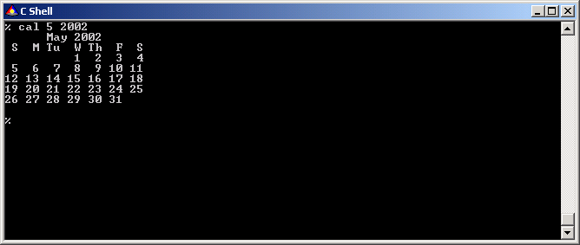

Figure 6. cal utility.
It is also possible to see the calendar for the entire year.
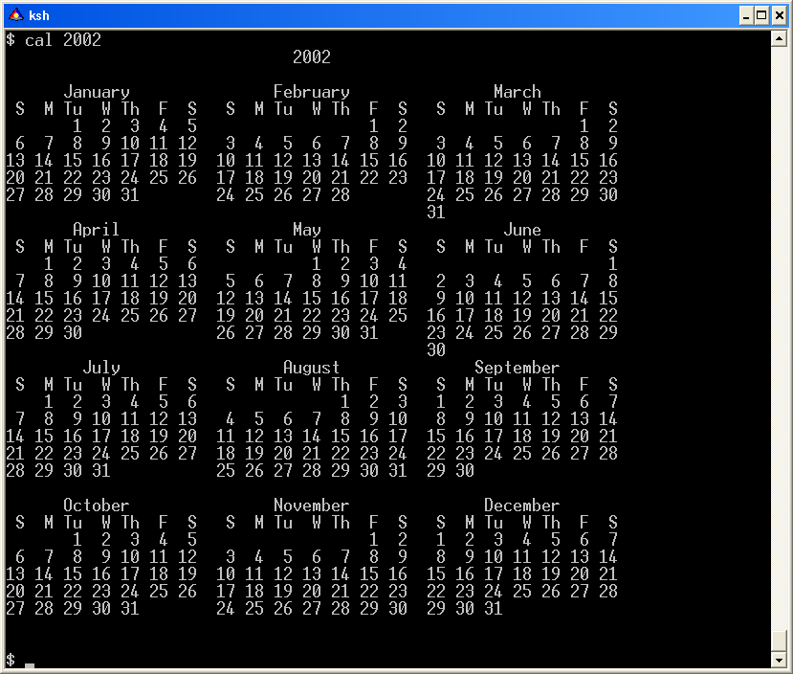
sort – a utility that sorts files

Figure 7. cal utility. Calendar for the entire year.
uniq – a utility that eliminates duplicate lines in sorted files
cat – a utility that writes file to a standard output in a particular format
Example: cleaning up a sample shopping list
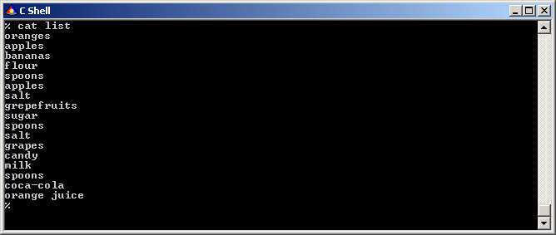

Figure 8. cat utility.

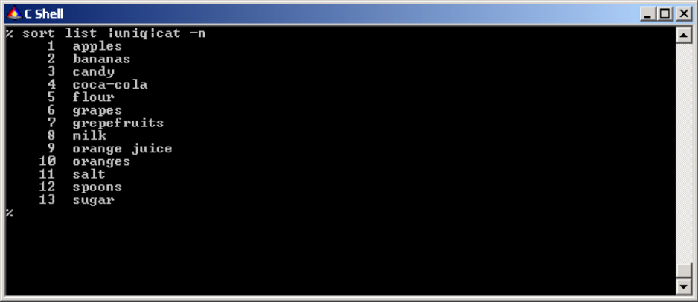
head – a utility that lists the first n lines of the file

Figure 9. sort utility.
tail – a utility that lists n last lines of the file
grep – a utility that selects the line in the file containing (or not containing) a particular string
wc – a utility that counts lines, words, and characters
Example: a sample application creates log files january.log, february.log, etc. as displayed
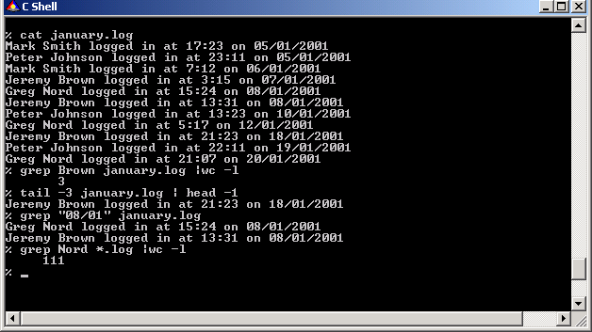
The following simple set of commands answers the following questions:

Figure 10. head and tail utilities.
- How many times did J. Brown log in during January?
- Who was the third last person to log in during January?
- How many logins were there on 08/01/2001
- How many times in 2001 did G. Nord log in?
ps – a utility that lists running processes
cut – a utility that extracts particular columns from the file
Example: list all uses of the notepad program and the time corresponding instances were started.
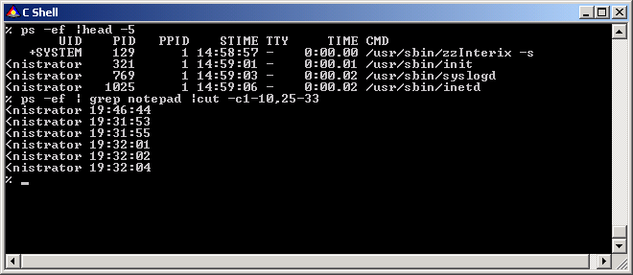
find – a utility that searches for files with particular characteristics

Figure 11. ps utility.
touch – a utility that changes file access and modification times. It can also be used to create blank files
Example: Create /tmp directory, populate it with *.txt and *.log files. Selective delete *.log files. Verify that *.txt files are intact.
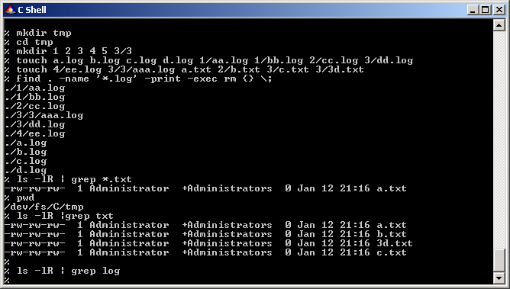
df – a utility showing free space on devices

Figure 12. find and grep utilities.
du – a utility showing space used by a given file or directory
Examples: perform the following functions:
- Find the amount of available space on all hard drives
- Find the size of C:\WINNT directory
- Find the largest file in C:\WINNT directory and display all information about it
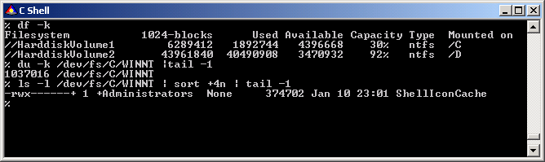

Regular Expressions and Pattern Matching

Figure 13. df utility.
A regular expression is an abbreviated representation of a pattern of characters. Regular expressions are used for search and search-and-replace operations, both of which require finding a string of characters on a line. Regular expressions, used in the utilities awk(1), ed(1), ex(1), expr(1), egrep(1), grep(1), more(1), sed(1), and vi(1), have the following limitations:
- Regular expressions do not usually span lines. You can, however, search across line breaks with grep.
- Some patterns are very difficult to express as regular expressions.
Regular expressions refer to a pattern and to the characters that the pattern matches. They are similar to shell wildcards (or globbing). For example, the shell wildcard * matches all file names, the shell wildcard A* matches all file names that start with A, and so on. Regular expressions work the same way, but are much more complex and powerful.
Most characters in a pattern represent themselves. For example, the letter a in a pattern matches the letter a in the target search string. When a simple pattern like hello matches the text string hello, it is said to match itself. Some characters in a pattern can represent more than just themselves. These are called metacharacters. For example, a dot (.) matches any single character. The ‘.’ is similar to the ‘?’ wildcard in a shell.
Some metacharacters depend on other characters in a string. For example, * has a special meaning only when it immediately follows another pattern; otherwise, it just matches *. Some metacharacters depend on the utility being used. For example, ex and vi have several unique metacharacters.
A large pattern is built from multiple, smaller patterns. For example, the pattern ab is made of two patterns, a and b. It matches ab; that is, it finds the string ab in a line. The pattern a. is made of the patterns a and .. It matches an a followed by any other character. The pattern a. will not, however, match an a at the end of a line, because there is no character following the a.
Based on the use of their metacharacters, regular expressions can be placed into two categories: basic regular expressions and extended regular expressions. Extended regular expressions are more flexible and powerful than basic regular expressions. Both kinds of regular expressions use character sets or bracket expressions.

File Editing
The most common editors in the UNIX world are vi and emacs. In addition to these editors UNIX also has stream editors (ts, sed, and awk), which scan files and perform specified actions against characters and lines (they are usually used during batch processing of text files in scripts).
tr – a utility used to translate characters
Example: Perform the following actions:
- List the first three lines of the shopping list
- Convert these lines to uppercase
- Replace end-of-line characters with spaces
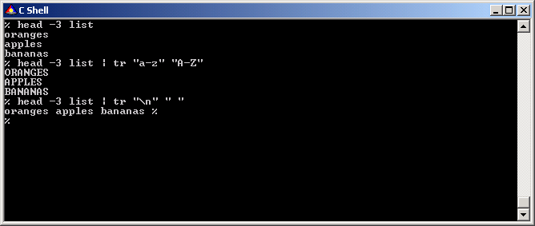

Figure 14. Line editing with tr utility.
sed – a line-oriented file editor
Example: perform the following actions:
- Display the shopping list file (“cat list”)
- Cut out all the lines from seventh down (“sed ‘7,$d’”)
- Perform global substitution of “apples” with “mango” in the shopping list (“sed ‘s/apples/mango/g’”)
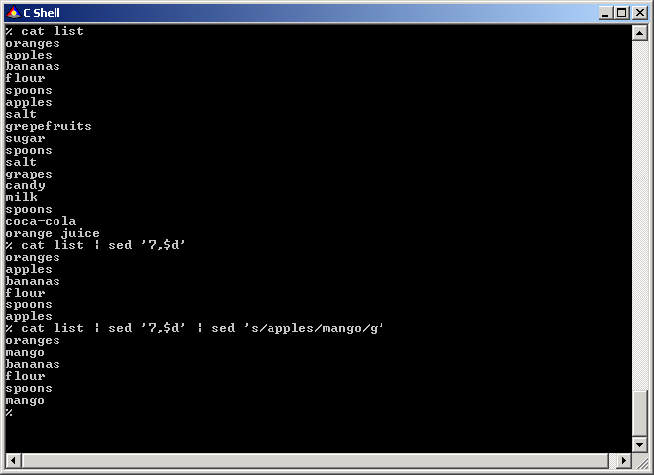

Typical Use of UNIX Utilities
While solving everyday problems, administrators often face tasks that require extensive data processing work, manual file editing, or repetitive use of the same utilities. In UNIX, these tasks are decomposed into a set of primitive tasks, each task is then solved by employment of a custom utility, and elementary tasks are re-assembled into a macro task by pipelining or batch processing. For example, to count the number of logins by a particular user, an administrator has to count the number of lines with a given string in a system log. The administrator may manually count the lines in a text editor or automatically by running a search with the grep command followed by a line count with wc –l command.

Figure 15. File line editing with sed utility.

Help System
A large number of UNIX commands supported by Windows Services for UNIX 3.5 have similar command-line parameters. To avoid mixing things up, administrators can use two help systems available in SFU:
- The man command, available from the shell, generates the appropriate manual pages for each UNIX command.
- Windows help system based on the several hierarchical *.CHM files viewed and searched with the Microsoft HTML Help Viewer

UNIX daemons are applications loaded with the operating system and run as services. These are similar to DOS TSR programs or Windows services. Special directories used in UNIX configure the initialization of daemons (usually /etc/rc2.d or /etc/init.d). These directories contain files describing launching and stopping of the corresponding daemon. For compatibility, Microsoft Services for UNIX comes with both /etc/rc2.d and /etc/init.d directories. However, in order to start the daemons with Interix init, the startup scripts must be executable and in the /etc/rc2.d directory. In the standard installation of Microsoft Services for UNIX cron and inetd are started automatically. Other services can be started manually or configured for auto-start.

unix daemons
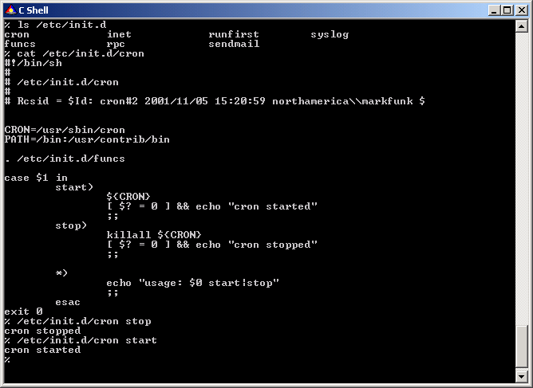

cron Scheduler

Figure 16. Listing of cron autoloader.
UNIX tasks can be submitted for automatic execution with the cron scheduler. cron is supported by both the Interix and Win32 subsystems. cron jobs are submitted by a Windows command-line. The crontab utility manipulates crontab entries, constituting of a list of commands and when they should be run in the background. A crontab file contains instructions to the cron daemon in the general form: run this command at this time on this date. Each user who has been assigned cron privileges has his or her own crontab file. cron can also send an e-mail as a result of running commands in the crontab. In Interix, in order to use cron, you must first use the ‘crontab –p’ command to store the password in the secret area of the registry. This is similar to running Windows services as a particular user. cron jobs are run as a particular user, so in order to have the job run as the appropriate user, the password must be used to correctly identify the cron user.
The format of a cron command very simple: each line has five time-and-date fields, followed by a command. Commands are executed by cron when the minute, hour, and month of year fields match the current time, and when at least one of the two day fields (day of month, or day of week) match the current time. The cron utility examines cron entries once every minute. The time and date fields are the following:
Field | Allowed values
minute | 0-59
hour | 0-23
day of month | 0-31
month | 0-12 (or names)
day of week | 0-7 (0 or 7 is Sun, or names)
A field can be an asterisk (*), which always stands for first-last. Ranges of numbers are allowed. Ranges are two numbers separated with a hyphen (-). The specified range is inclusive. For example, 8-11 for an hours entry specifies execution at hours 8, 9, 10, and 11. Lists are allowed. A list is a set of numbers (or ranges) separated by commas. Examples: 1,2,5,9, 0-4,8-12. Step values can be used in conjunction with ranges. Following a range with /<number> specifier skips of the number's value through the range. For example, 0-23/2 can be used in the hour field to specify command execution every other hour (the alternative in the V7 standard is 0,2,4,6,8,10,12,14,16,18,20,22). Steps are also permitted after an asterisk, so if you want to specify every two hours, use */2. Names can also be used for the month and day-of-week fields. Use the first three letters of the particular day or month (it is not case sensitive). Ranges or lists of names are not allowed.
The sixth field (the rest of the line) specifies the command to be run. The entire command portion of the line, up to a newline or % character, will be executed by /bin/sh or by the shell specified in the SHELL variable of the cronfile. Percent signs (%) in the command, unless escaped with backslash (\), will be changed into newline characters, and all data after the first % will be sent to the command as standard input.
For example, 30 4 1,15 * 5 cron entry would cause a command to be run at 4:30 am on the first and fifteenth of each month, plus every Friday.

syslogd
syslogd logs different aspects of system activity and is configured by /etc/syslog.conf. By default, most logging is disabled off but can be enabled by uncommenting the corresponding lines in the /etc/syslog.conf configuration file and restarting syslogd. The logs are stored in text files; this simplifies the development of the automatic log management scripts. The logs can be divided by parts and compressed with the gzip utility to save disk space. You should note that, by default, logging is only done to /dev/console. This means that no system messages will be saved, since /dev/console is not persistent storage.
Following is the listing of the syslog configuration file:
# /etc/syslog.conf
#
# RCSid = $Id: syslog.conf,v 1.8 1999/07/21 18:08:25 mark Exp $
#
#
# -- We try to keep all files in /var/adm/log regardless of their basename.
# -- This should keep it simpler for log scans and rotations, but you
# -- can change this if you already have site preferences.
# -- Each file must exist when syslogd is started if you want information
# -- to be logged to that file; syslogd will not create files.
# -- For more information see the man page "syslog.conf".
#

*.err;kern.*;auth.notice;authpriv.none;mail.crit /dev/console

# -- NOTE: the following files (messages, lpr, mail, ..)
# -- have already been created during the installation of Interix.
# -- Uncomment out the following entries to which you want syslogd
# -- to write information.

# *.notice;*.info;authpriv,ftp.none;kern.debug;mail.crit /var/adm/log/messages
# lpr.info /var/adm/log/lpr
# mail.* /var/adm/log/mail
# uucp.info /var/adm/log/uucp
# ftp.* /var/adm/log/ftp
# daemon.* /var/adm/log/daemon
# news.* /var/adm/log/news

# -- The authpriv log file should be restricted access; these
# -- messages shouldn't go to terminals or publicly-readable
# -- files.
#
# authpriv.* /var/adm/log/secure

#
# The following are commented out for the Administrator to turn on
# if desired. As mentioned on the man page, user names are to be prefixed
# with the name of the domain. Since we don't know yours (and it won't
# always be that domainname equals machinename) "<DOMAIN>" should be
# replaced with the domainname of your choice.
#
# *.emerg *
# *.alert <DOMAIN>+Administrator
# *.err,authpriv.none <DOMAIN>+Administrator
# *.notice;auth.debug <DOMAIN>+Administrator

inetd
inetd is a super-daemon that controls the most common Internet services such as telnet, shell, finger, ntalk, ftp, pop3, rlogin, and tftp. The /etc/inetd.conf file controls the parameters of these services. In order to start a particular service, its Windows counterpart has to be stopped. By default, neither telnetd or rshd are configured for use.
Following is the listing of the inetd.conf file:
#
#----------------------------------------------
# RCSID = $Header: /E/interix/src/etc.files/inetd.conf,v 1.17 1999/03/20 08:06:07 rodney Exp $
#
# Filename: /etc/inetd.conf
# Internet server configuration database
#
# Leave the pathnames in column 6 as given below.
# Inetd will automatically prefix the path with the Interix installation
# location to form the full absolute pathname.
#
# Tftp is commented out so that it does not start by default at your site;
# you may want to start it for various reasons (like X-terminals);
# please read the tftpd man page.
#
#
# Format of each line below:
# serviceName
# SocketType
# Protocol
# wait/nowait
# userName - for Interix this is ignored
# program
# arguments ...
#
#
# NOTE: Services For UNIX ships with two different telnet servers
# and rsh servers.
# The Windows version is enabled by default.
# To enable the Interix versions, then uncomment out the next
# two lines.
# BEWARE: you need to disable the Windows version of
# these services first.
#
#telnet stream tcp nowait NULL /usr/sbin/in.telnetd in.telnetd -i
#shell stream tcp nowait NULL /usr/sbin/in.rshd in.rshd -a
#
exec stream tcp nowait NULL /usr/sbin/in.rexecd in.rexecd
finger stream tcp nowait NULL /usr/sbin/in.fingerd in.fingerd -ls
ftp stream tcp nowait NULL /usr/sbin/in.ftpd in.ftpd -l
login stream tcp nowait NULL /usr/sbin/in.rlogind in.rlogind -a
ntalk dgram udp wait NULL /usr/sbin/in.ntalkd in.ntalkd
#tftp dgram udp wait NULL /usr/sbin/in.tftpd in.tftpd -l /tftp_dir
pop3 stream tcp nowait NULL /usr/sbin/popper popper
#
# internals below here
#
tcpmux stream tcp nowait NULL internal
echo stream tcp nowait NULL internal
discard stream tcp nowait NULL internal
chargen stream tcp nowait NULL internal
daytime stream tcp nowait NULL internal
time stream tcp nowait NULL internal
echo dgram udp wait NULL internal
discard dgram udp wait NULL internal
chargen dgram udp wait NULL internal
daytime dgram udp wait NULL internal
time dgram udp wait NULL internal

sendmail
sendmail is the most popular UNIX mail daemon. In SFU, the sendmail daemon is disabled by default and must be started manually. The configuration of the sendmail server is such that the PSS organization will not assist users in configuring sendmail as a server. For instructions on configuring sendmail, O’Reilly and Associates offers an excellent book.

dns
The /etc/resolv.conf file configures DNS settings in SFU. If a local caching daemon is required to speed up the lookup process for a large number of DNS requests, administrators can execute built-in BIND (/usr/sbin/named).
Windows applications use the Win32 application programming interface (API), implemented by the Win32 subsystem. Programs written for MS-DOS, OS/2, Windows 3.x, and POSIX run in their own environmental subsystems, which interact extensively with the Win32 subsystem to provide functionality. The Interix subsystem is an independent subsystem that implements POSIX application programming interfaces. Even with this independence, administrators can still run Win32 programs from an Interix shell prompt.

calling Win32 applications from interix
On UNIX systems, system services are handled by server programs, which are usually called daemons. Windows has its own server-level programs, which are called services. Unlike daemons, services log on to the computer with a user account. Because services work this way, administrators have control over the privileges granted the service and, when the service logs on with a domain account, services have controlled access network resources. To run Interix programs as Windows services, Interix includes a utility called service to administer Interix services. The service utility registers, installs, starts, and stops an Interix program run as a service.
The service utility can install Interix applications as Windows services using the psxrun.exe application installed by SFU in the WINDOWS\system32 directory. A service has no console display. Administrators cannot send a signal to a service using the kill utility but can stop the service in Windows through a command line or management console or, in Interix, with the service utility. The service utility can do the following:
- List all running services. This is available to everyone, not just administrators.
- Grant the service-logon privilege to a user. Administrator access is required.
- Revoke the service-logon privilege from a user. Administrator access is required.
- Start a service. Administrator access is required.
- Stop a service. Administrator access is required.
- Remove a user's service. This stops and uninstalls a service, but the user still has the right to start another service. Administrator access is required.
The administrator can rely on SFU utilities compiled for Win32 environment to manage the computer from the Windows environment. This is extremely helpful for UNIX administrators rely on Perl scripts and vi in both Win32 and Interix subsystems. ActiveState Perl has modules for Win32 environment to support working with the registry, sending mail with MAPI, ODBC interface with RDBMSes, and EventLog management (similar to syslog logs management in UNIX). These functions help automate the management of the Win32 environment in a manner similar to the UNIX environment.

administration in the win32 environment
From a scripting and application code portability perspective, Interix and UNIX are virtually the same. But from a security standpoint, Interix is a subsystem that relies on the underlying Win32 operating system to manage system security. For the UNIX system administrator starting to work with Interix for the first time there are some key differences. First of all, unlike in UNIX security, users and groups share the same namespace in the Security Access database, rather than groups and users being separate (for example: /etc/passwd, /etc/ group). In a Windows domain, user and group information is stored in Active Directory, and all group and user names in a given domain must be unique. Furthermore, no group can have a user's name or vice versa. Active Directory replaces the common UNIX /etc/passwd and /etc/group files. An Interix system administrator must create and maintain users and groups with either the Active Directory Users and Computers or the command line net user command. (Example shell scripts to create and remove users are included in the directory /usr/examples/admin.)

interix systems security

Root/Superuser Privileges
On most UNIX based systems, a root or superuser has complete control of the system. The Interix subsystem does not recognize a single root/superuser account as such, because the UNIX root user account has system-wide powers that are not automatically assigned to any one user on Windows. On Interix, the Administrator account is closest in power and privileges to the UNIX root user. The primary reason for this discrepancy is that permissions are not implemented the same way on Windows as they are on traditional UNIX systems, and since Interix relies on Windows to manage security, it defers all low-level security semantics to Windows. That said, two accounts are treated specially by Interix: the local Administrator account and the domain Administrator account.
NOTE: Both of these accounts have well known SID values and thus well-known Interix UID values, even though the account might have a name other than "Administrator."
These special accounts are allowed to behave as if they had additional rights and privileges above and beyond the privileges assigned to those accounts by Windows. Therefore, Interix essentially treats these accounts as UNIX treats the "root" user (or the account with a uid of 0).
Superuser privileges are typically required for actions such as modifying file-system access permissions and for executing certain process control actions (such as sending signals to other processes, killing processes, and others). For changing the effective user identifier (ID) or group ID of a process in such a way that it changes the ability of the process to perform certain actions, superuser level privileges are also required. The calls associated most often with appropriate privileges are setuid(2) and setgid(2) (and their variants), and chroot(2).
The following privileges allow any user/group account to act as the traditional superuser for certain Interix system calls:

Call | Windows privilege
chgrp() | SE_BACKUP, SE_RESTORE
chmod() | SE_BACKUP, SE_RESTORE
chown() | SE_BACKUP, SE_RESTORE
chroot() | SID of SYSTEM, local+Administrator or pdomain+Administrator
kill() | SE_SECURITY_NAME or SE_TCB_NAME
renamewtmpx() | SE_SECURITY_NAME
set*[gu]id() | SID of SYSTEM or {local,pdomain}+Administrator
Most of these calls rely on Windows privileges associated with the calling process, but the set*id() calls rely on the Windows security ID of the calling function.
All objects in Windows residing on an NTFS file system have an owner and a primary group. Furthermore, each secure NTFS object has a discretionary access control list (DACL) made up of access control entries (ACE). Each ACE applies to a particular group or user and either allows or denies a type of access to that group or user. You can see the DACL for a secure object by using the Windows cacls command, or by right-clicking the object, clicking Properties menu, clicking the Security tab, and then clicking Permissions. Each user or group with access has its permissions listed with respect to the object, as described in the following list:

windows object security
- Deny full access – The user or group cannot open or change the file, even if membership in a group would otherwise allow it.
- Read and execute – The user or group can view or execute the contents of the file, but not change or delete it.
- Read – The user or group can view the contents of the file, but cannot execute it.
- Modify – The user or group can save changes to the file or its attributes, but not its permissions or owner. The user or group can also delete the file.
- Full control – The user or group has complete control over the file, including changing its permissions or owner.
- Special permissions – The permissions assigned to the user or group consists of a combination of specific permissions that do not correspond to any of the preceding named permissions.

Directory Security
Directories have somewhat different permissions from files. In addition to specifying the access permission for the directory itself, directory permissions also specify the default permission inherited by files in that directory:
- Deny full access – The user or group cannot list the files in the directory. Unless the permissions of a particular file explicitly allow it, the user or group cannot access files in the directory.
- List folder contents – The user or group can list the files in the directory. Unless the permissions of a particular file explicitly allow it, the user or group cannot access files in the directory.
- Read and execute – The user or group can list the files in the directory. Unless the permissions of a particular file provide otherwise, the user or group can view or execute the contents of files in the directory.
- Read – The user or group can list the files in the directory. Unless the permissions of a particular file provide otherwise, the user or group can view the contents of files in the directory, but not execute them.
- Write – The user or group can create files in the directory, but not list files in the directory. Unless the permissions of a particular file provide otherwise, the user or group can change contents of files in the directory.
- Change – The user or group can create and list files in the directory. Unless the permissions on a particular file provide otherwise, the user or group can read, execute, change, or delete files in the directory.
- Full control – The user or group has complete control over the directory and (unless individual file permissions specify otherwise) its files, including changing its permissions or owner.
A file created through Interix and viewed using the ls -l command has the following permissions and attributes:
- The file is owned by the user who created it.
- The file’s group is the same as the group of the directory.
- File permissions are dictated by the file creation mask and the user mask (see umask(1)).
POSIX files are given three ACEs: one for the owner, one for the group, and one for the group Everyone, which represents everyone else. POSIX permissions are represented as follows:
- The POSIX read permission is represented by the Windows permission.
- The POSIX write permission is represented by the Windows write permission. If the file's read-only attribute is set, the Interix subsystem does not assign write permission, regardless of the contents of the ACEs. (Using chmod(1) to assign write permission to a file with the read-only attribute set removes the read-only attribute.)
- The POSIX execute permission is represented by the Windows execute permission, which is implicit in several standard permissions.
- The owner also has permission to change permissions and to take ownership of the file.
A file created through the Win32 subsystem can have a different number of ACEs associated with it, and those ACEs might not fit well into the categories of user, group, and other. Interix tools will assemble permissions from the available ACEs, accordingly:
- The file is owned by the user unless the user is a member of the Administrators group, in which case the file is owned by the Administrators group.
- The file's group is determined by the group membership of the owner.
- If the owner has no specific ACE associated with it, the owner permission bits are empty.
- If the owner is a group, those permissions will be used as the owner's permission, and the group permissions will be empty.
- The "other" permissions are those of the built-in group Everyone.
If the ACE used to determine the owner's permissions does not have change permission or take-ownership permission, the ability of the utilities chown(1), chgrp(1), and chmod(1) to change file, ownership, group membership, or read/write/execute permissions might be hampered.
Different domains can have users with the same login name. The combination domain\username is unique on a particular network so, for example, the user represented by DEV\chris is not the user represented by ADMIN\chris. The Windows idiom for specifying a domain and a user name is domain\username. Interix utilities return usernames using the syntax domain+username, but will accept the following forms where a user name would usually go:

domains and user names
- domain\username
- domain+username
Interix uses a "principal domain" as its default security namespace. When working with Interix utilities, if no domain name is specified, a user or group is assumed to belong to the principal domain. The principal domain is a system-wide concept. By default, it is the Windows domain to which the computer belongs, unless the computer belongs to a workgroup, in which case the principal domain is the name of the computer itself. If the domain of a user or group matches the computer's principal domain, Interix omits the domain name when displaying the user or group name. When passing a user or group name parameter with its associated domain, the above notations can be used. If you use the backslash syntax in an Interix shell, as in:
$ id domain\\joeuser
You must use a double backslash to escape the desired backslash character, because ‘\’ is the standard shell escape character.
A single plus sign (+) can be used as a shorthand prefix to any User or Group account. If this is done (for example: +barryc), then Interix looks to regard this account name as if it is an account in one of the default local system domains, such as BUILTIN or NT AUTHORITY. If Interix cannot find the account there, it looks in the local user/group database. If Interix still fails to find the +account it seeks in any of the local domains, then Interix will secondarily look in the principal domain for the account. Here are a few examples to illustrate the point:
+SYSTEM = NT Authority\SYSTEM
+Administrator = <localComputer>\Administrator
+username = <localComputer>\username
(or)
+username = <principalDomain>\username
(depending on where “username” actually resides.)
Most UNIX shell scripts run under Interix without a problem. This section describes execution of the shell scripts and Perl script.

Script porting

Shell Scripts
The following shell scripts are useful for UNIX administration. The allfiles script executes a given command in all the subdirectories of a tree. The rmemptydir script deletes all empty directories in the tree. To test the scripts, perform the following actions:
- Download script from the following URL http://oase-shareware.org/shell/scripts/cmds/allfiles.txt and save it as allfiles. The script is included in Appendix B if the link is unavailable.
- Download script from the following URL file http://oase-shareware.org/shell/scripts/quickies/rmemptydir.txt and save it as rmemptydir. The script is included in Appendix C if the link is unavailable.
- Execute “mkdir 1 2 3 4 5; mkdir 4/4 4/5; ls –l >4/4/4” to create empty and non-empty directories.
- Execute “ls –lR” to print the tree structure.
- Execute “./allfiles ls” to get the listing of all non-empty subdirectories.
- Execute “./rmemptydir” to see the empty directories gone.
- Execute “ls –lR” to print the remaining tree structure.
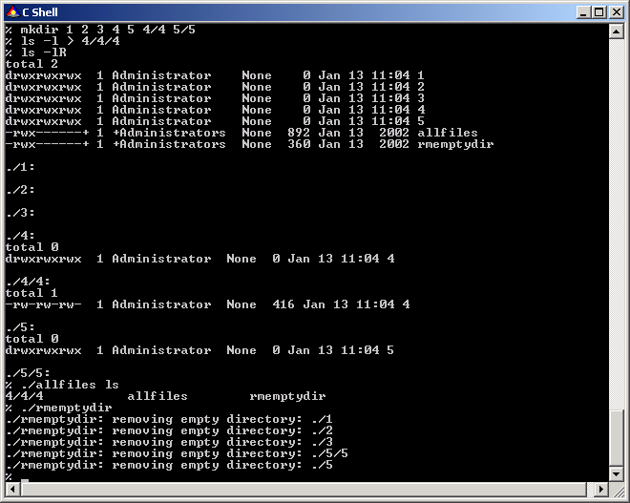

Figure 17. Execution of allfile script.
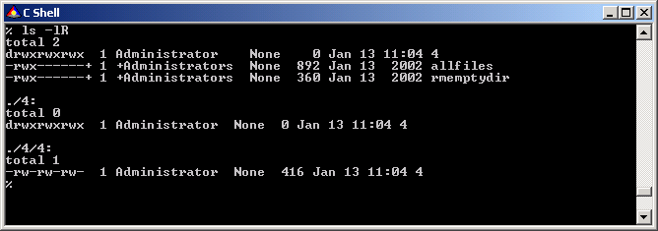

Figure 18. Testing results of execution of allfile script.

Perl Scripts
The following section describes the procedure of porting Perl scripts to Windows using Microsoft Services for UNIX. A variety of free Perl administration utilities and modules are available from CPAN (http://www.cpan.org/ ). This example describes the process of compilation of the log_analysis utility (http://linux.umbc.edu/~mabzug1/log_analysis.html) , which can be used to extract relevant data for any of the recognized log messages to produce a more readable summary. The program can be configured to recognize entirely new log types in addition to the kinds of syslog messages and wtmp messages that it was designed to process.
Perl is included with SFU and can be called from any directory since the location of Perl executables is included in the PATH (/usr/local/bin). Perl includes a variety of modules for file management, network access, e-mail processing, security management, and many more.

log_analysis script
This section describes installation of the log_analysis script. Let us go step-to-step through the process of execution of the utility.
- Make sure that the ftp service is not running on your computer.
- Enable ftp daemon by uncommenting the appropriate line in /etc/inetd.conf (line 56).
- Enable ftp logging by uncommenting the appropriate line in /etc/syslog.conf (lines 25, 33, 43, 44, and 45).
- Restart inetd and syslogd.
- Ftp to your Interix computer several times to populate the log.
- Check that the ftplog is populated.
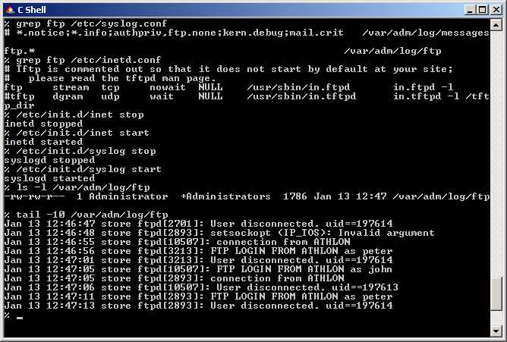

Figure 19. Testing the functionality of syslog by analyzing syslogentries.
- Unpack, compile, and execute the program.
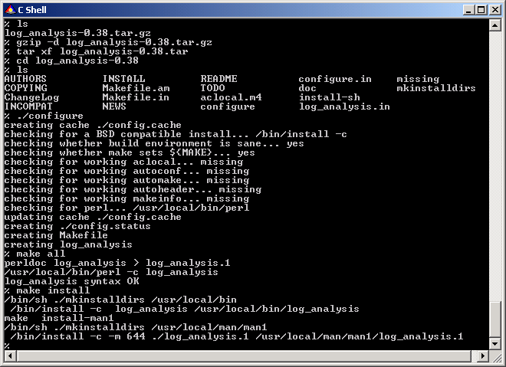

Figure 20. Compilation of log_analysis script.
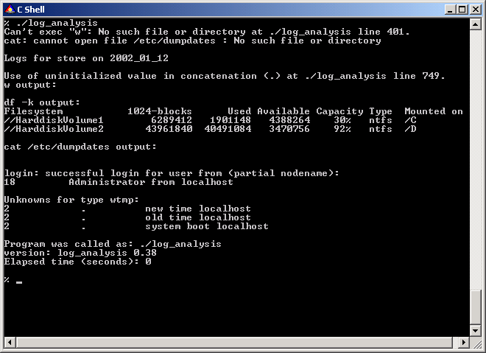
You will notice that there are some issues in running this script. The first error is “Can’t exec ‘w’. No such file or directory at ./log_analysis line 401.” This indicates that there is a problem with executing a binary in the script. Upon further analysis, you can see that the “w” command is not present on the Interix system, however, the “who” command is available. We can change the script to reflect this, or we can locate and port the “w” command.

Figure 21. Execution of log_analysis script.

daemonup.pl script
In similar fashion the daemonup.pl script can be ported. This script is executed periodically (usually by cron) to verify that the managed daemon running. If the daemon is not running, the script runs it and sends mail to notify the administrator. The script is very simple:

#!/usr/local/bin/perl
$|=1;
$MAILTO = 'admin@domain.net';
$MAILFROM = 'robot@domain.net';
$SUBJECT = 'Restart of DAEMON on SERVER ';
$MAILX = '/bin/mailx -s \'DAEMON restarted\' admin@domain.net';
$PS="/bin/ps -ax";
$GREP="/usr/bin/grep";

$pid=fork();
if ($pid==0) {
$pidm=`$PS | $GREP DAEMON | $GREP -v grep|wc -l`;
if ($pidm==0) {
open(MAIL,"| $MAILX");
print MAIL "DAEMON server restarted.\n";
print MAIL "\n";
close(MAIL);
exec("/usr/local/etc/rc.d/DAEMON.sh start");
}
}
exit(0);
The script is ported into Interix with no problem and can be automatically executed by cron every 15 minutes with the following cron entry:
15 * * * * /usr/local/util/daemonup.pl

Microsoft Windows Services for UNIX provides both the tools and the application programming interface (API) libraries for porting applications to Windows. With the Software Development Kit (SDK), administrators can host their own tools and applications alongside Windows Services for UNIX tools and programs.

Development and debugging tools
The SDK provides a front end for Microsoft Visual Studio with which C programs can be compiled. This provides a native UNIX environment for development based on a native Windows compiler. The development environment includes standard UNIX development tools such as the GNU gcc, g++, and g77 compilers, and the gdb debugger. Both gcc and g++ are ports of the popular GNU C compiler (version 3.3). The g77 front end is a port of g77 (version 3.3). All of these front ends eventually invoke the same compiler engine, hence the similarities.
The make utility in this release is based on the OpenBSD version of make. The lex and yacc utilities are based on flex and BSD yacc. The Revision Control System (RCS) utilities are based on the RCS 5.6 utilities.
The Interix SDK contains various interfaces and libraries. These include: the POSIX.1 interfaces; the POSIX.2 interfaces; the International Standards Organization/American National Standards Institute (ISO/ANSI) C libraries; many useful interfaces and libraries found on open systems; and libraries for lex, yacc, curses, and termcap. The Interix SDK also provides additional functionality such as X11, curses, db and rpc libraries.
The Interix Software Development Kit (SDK) supports shared (or dynamically linked) libraries. Dynamic linking is supported through standard calls; dlopen(), dlsym(), dlclose() and dlerror(). Dynamically linked applications and shared libraries can only be created using gcc(1) and the other GNU compiler tools. However, cc(1) and c89(1) will still produce statically linked binaries.
The Interix SDK also includes a command called liblock(1), which locks a library to prevent linking from using a library. If any process attempts to link using a locked library, the ld(1) command reports a fatal error. There is no tool provided to unlock a library that has been locked using liblock. The locking is not invulnerable and should not be regarded as a high-security option.
Developers can use the Interix SDK to create real, UNIX-style .so libraries. Although similar to Windows dynamic-link libraries (DLLs), they are not the same in implementation or semantics.
The Interix Software Development Kit (SDK) contains the GNU debugger, gdb(1). The debugger uses the /proc virtual file system to manipulate and control Interix applications. The debugger has certain limitations because it only provides useful information for object files compiled with gcc(1) and g++(1), not for files compiled with cc(1) or c89(1). It also does not implement watch points. The Interix implementation of the gdb debugger works with shared libraries; it also includes some additional commands. For more information, see the shared and info shared commands in the gdb help function.
Developers can convert existing makefiles to run under the Interix subsystem by changing macro definitions. The value of $(CFLAGS) must be edited to use only flags supported by cc(1) or c89(1).
Interix make provides the following extensions to POSIX.2:
- The special targets .BEGIN, .END, .INTERRUPT, .MAIN, .NOTMAIN, .MAKE, .MAKEFLAGS, .OPTIONAL, .PATH, and .USE.
- The special macros .TARGET, .OODATE, .PREFIX, .MEMBER, .IMPSRC, .ALLSRC, and .ARCHIVE.
- An include directive, .include, for including other files (the -I option specifies the directories to search for those other files).
- Conditionals such as .if, .ifdef, .ifmake, and so on. See the make reference page for more details on these extensions.
The Interix subsystem gives SFU a familiar and UNIX-compatible scripting and programming environment with support for multiple languages and libraries. These include Perl, C, fortran77, and C++. SFU 3.5 provides updated versions of the GNU programming languages and tools, optimized for SFU, as part of the GNU SDK.

porting applications

Tools and Utilities
Since all the standard UNIX tools and utilities are part of SFU, there is no need to purchase an add-on package from a third party to get the tools you expect and require in order to get your work done. All the familiar tools are available and work exactly as a UNIX administrator would expect. The utilities include familiar text processing tools, such as grep, less, awk, sed, pr, tr, etc.; batch processing tools such as at, cron and batch; as well as job control tools such as ps, nice, and kill; graphic utilities such as xterm, xrdb, xset and xclock; development tools such gcc, gdb, and make, and connectivity tools such as bind, sendmail, and ftp. They are all there, and work exactly as you would expect. Even man is just the same as it has always been.
Additional Open Source tools are now available from http://www.interopsystems.com/tools, including OpenSSH and OpenSSL, bash, gmake, awk, pkg-config, free TDS CVS, bzip and dozens of others in an expanding list.

Programming
Interix not only provides a full set of APIs, compilers, and utilities for creating and migrating UNIX applications, but it also provides a complete environment that behaves exactly as UNIX applications expect. This makes it not only possible but also relatively easy to port existing UNIX applications to run under Interix.
In SFU v3.5, more than a hundred new APIs are introduced to support pthread applications and internationalization. The inclusion of pthread support as of version 3.5 greatly extends the compatibility of the Interix subsystem to host pthread-compliant UNIX applications originally developed on a supported platform.

X Windows
The Interix SDK includes X11 libraries, header files, and various tools for building X Windows applications. However, SFU does not include an X Windows server, which means that X Windows applications that need to be displayed on the local workstation will need an X Windows server installed.
Most code written for X Windows assumes a directory structure of /usr/X11, but Interix uses a version specific directory structure, /usr/X11Rn, where n is replaced with the release level of X11. This difference is best handled by creating a symbolic link to point to the new directory and does not require any code changes in applications. SFU 3.0 only included X11R5; however, for those applications that require a later version of X11, X11R6.6 ships natively in the 3.5 version of Services for UNIX.

Curses
For character mode applications that use curses, the Interix SDK includes the ncurses implementation of curses written by Eric S. Raymond and Zeyd M. Ben-Halim. This highly compatible and robust implementation of curses comes with full documentation for writing curses applications and the specifics of the ncurses implementation in the SFU Help application.

Symbolic Links
Another important addition to Interix in SFU is full support for symbolic links. Symbolic links let users easily manage file locations by placing files and directories wherever desired while maintaining access to those files and directories in their "standard" location, even across file system boundaries. For example, a developer will often have a symbolic link between /usr/local/bin and ./bin in their home directory.
ln –s /dev/fs/U/bin /usr/local/bin
This gives developers the convenience of maintaining a central binary directory containing all of their most frequently used scripts, applications, and utilities across several computers.
Another use of symbolic links is to provide a more Windows-centric access to various drive letters. A developer might, for example, create symbolic links that allow a user to access standard windows drives with a simple "/c" or "/C" instead of "/dev/fs/C."

rinetd
rinetd is a utility that redirects TCP connections from one IP address and port to another. It is useful in architecting site or host security by rerouting services between the internal and external computers on configurable ports. rinetd is a single-process server which handles any number of connections to the address/port pairs specified in the file /etc/rinetd.conf. Since rinetd runs as a single process using nonblocking I/O, it is able to redirect a large number of connections without a severe impact on the machine. This makes its applicability for IP masquerading even more practical. rinetd also supports basic allow/deny access control and logging but does not redirect services using more than one socket (FTP) or using dynamic port negotiation (H.323).
To test the functionality of the Interix subsystem, perform the following actions:
- Type “gcc –c getopt.c”
- Type “gcc –c match.c”
- Type “gcc –c rinetd.c”
- Type “gcc –o rinetd –I . –DLINUX rinetd.o match.o getopt.o”
- Edit the /etc/rinetd.conf file to add the following line: “127.0.0.1 8025 127.0.0.1 25”
- Telnet to port 8025 to see the sendmail prompt (if you have started the sendmail server).

NEWSYSLOGD
During the process of installation of a system application, the administrator performs the following set of steps:
- Download the compressed source code
- Uncompress the code
- Compile the code
- Configure the application
- Make the an application auto-startable through /etc/init.d or through /etc/init.d/inet for network applications
- Configure syslog to store the logs of the application in a separate file
- Rotate logs
- Monitor the application and create auto-restart facility to restart an application after abnormal termination. A separate script that informs the administrator of the problems related to the application should be created.
Most of these tasks are accomplished in SFU except for log rotation, which seems to be a problem for most applications. Most systems administrators use NEWSYSLOG available at http://freshmeat.net/projects/newsyslog/ to rotate logs.
The compilation of the application poses several problems, which will be demonstrated and resolved.

Principles of Porting the Code
The Interix subsystem is, at its base, a POSIX.1-conformant subsystem. It also supports a variety of features, including sockets, Berkeley Software Distribution (BSD) 4.4 interfaces, System V interprocess communication (IPC) mechanisms, pseudo terminals, and memory mapped files. Most of the UNIX95 programming interfaces are available with SFU 3.5. Applications are often written for one operating system and ported to another by using some combination of conditional compilation (#ifdef preprocessor commands) or wrapper functions. Porting software to the Interix subsystem involves:
- Making the source portable. That is, choosing the features supported by the Interix subsystem. These features include the POSIX.1 interface, as well as extensions taken from other standards, such as the Single UNIX Specification, and extensions taken from traditional systems, such as BSD or System V derivatives.
- Addressing issues specific to the Interix subsystem.
Programs are usually ported by typing make(1) in the source directory. After you have done this, you can fix problems reported by the compiler. The following changes are some of the most common you might need to make:
- Select the appropriate compile flags for a POSIX.1 system.
- Replace the VARARGS macros with STDARG macros. Although both macro sets are provided, the STDARG macros are standard.

Compilation of NEWSYSLOG Application
Perform the following actions:
- Since the software is built with autoconf, which automatically creates Makefiles, the corresponding supporting applications must be downloaded and installed. Therefore:
  - Download ftp://ftp.gnu.org/gnu/autoconf/autoconf-2.52.tar.gz
  - Download ftp://ftp.gnu.org/gnu/automake/automake-1.5.tar.gz
  - Download ftp://ftp.gnu.org/gnu/m4/m4-1.4.tar.gz
  - Download newsyslog.tag.gz from http://freshmeat.net/projects/newsyslog/
  - Rename the old m4executable: “mv /bin/m4 /bin/m4.old”
- Compile and install the applications. Execute:
  - “gzip –d m4-1.4.tar.gz”
  - “tar xvf m4-1.4.tar”
  - “cd m4-1.4”
  - “./configure”
  - “make all && make install”
  - perform the same actions for autoconf and automake
- Attempt to compile and install newsyslog. Execute:
  - “gzip –d newsyslog.tar.gz”
  - “tar xvf newsyslog.tar”
  - “cd newsyslog”
  - “./configure”
  - “make all”
We have arrived at the first error - the LOCK_EX constant is undeclared:
gcc -DHAVE_CONFIG_H -I. -I. -I. -g -O2 -c newsyslog.c
newsyslog.c: In function `parse_options':
newsyslog.c:401: warning: assignment makes pointer from integer without a cast
newsyslog.c: In function `parse_file':
newsyslog.c:543: `LOCK_EX' undeclared (first use this function)
newsyslog.c:543: (Each undeclared identifier is reported only once
newsyslog.c:543: for each function it appears in.)
newsyslog.c:543: `LOCK_NB' undeclared (first use this function)
newsyslog.c:544: warning: assignment makes pointer from integer without a cast
*** Error code 1
By looking at the line number (543) that reported the error, we can see that this constant was used in the fcntl function defined in /usr/include/fcntl.h. However the file is already included since newsyslog.c contains the line with “#include <fcntl.h>”. Analysis of the fcntl.h file shows that an additional parameter is required in the makefile to have all constants included in the compilation process. Therefore, we change
DEFS = -DHAVE_CONFIG_H -I. -I$(srcdir) -I.
in Makefile to:
DEFS = -DHAVE_CONFIG_H -D_ALL_SOURCE -I. -I$(srcdir) -I.
Then we arrive at the second error:
gcc -DHAVE_CONFIG_H -D_ALL_SOURCE -I. -I. -I. -g -O2 -c newsyslog.c
gcc -o newsyslog newsyslog.o
newsyslog.o: In function `check_file_size':
/dev/fs/D/kvn/distr/newsyslog-1.0.100/newsyslog.c:1254: undefined reference to `
dbtob'
*** Error code 1
The dbtob function is found in the same file but is only included in compilation with the _IBMR2 option. The dbtob function is used to convert file sizes from 512-byte blocks to bytes. In order to fix the compilation process, the following line has to be added to newsyslog.c:
#define dbtob(db) ((unsigned)(db) << 9) /* Calculates (db * DEV_BSIZE) */
Now the program can be compiled properly.
However, upon executing the program we arrive at the third error:
$ ./newsyslog
newsyslog: you do not have root privileges
This is strange since we logged in as Administrator. The fact is that UNIX requires superuser privileges (root, with UID=0), which are reported to the code by getuid function. If getuid returns a non-zero, then the privileged operation (log rotation in our case) is not allowed and the program terminates abnormally. Since every Windows user has its own identifier (SID), it is used in Interix as UID. There are a few well known uids in the Interix environment, for example:
197108 local system administrator
1049076 primary domain administrator
66834 LOCAL SYSTEM CONTEXT
So instead of checking whether you are uid 0 to determine if you are the root user, you can check for the above UIDs.
We finally have to remove the lines checking for UID (searching newsyslog.c by substring “root privileges”) and recompile the code. Upon successful compilation the program can be added to the cron scheduler to be run once a day at 4 a.m. with the following crontab entry:
0 4 * * * /bin/newsyslog
User Name Mapping provides centralized credentials mapping services for Interix, Client for NFS, Gateway for NFS, Server for NFS, and Remote Shell service. It allows administrators to create one-to-one and many-to-one maps between Windows and UNIX user and group accounts (even though the user and group names in both environments may not be identical), and to maintain a single mapping database for the entire enterprise. The many-to-one mapping feature allows administrators to associate multiple Windows accounts with a single UNIX account in cases where only few accounts are required on UNIX to provide different classes of access permission (e.g., Java developers, Web developers, DB administrators, backup operators, etc.). User Name Mapping obtains UNIX user, password, and group information from one or more NIS servers (or from passwd and group files copied locally by a PCNFS daemon).

user name mapping
User Name Mapping periodically refreshes its username list from the source databases (NIS or PCNFS on UNIX, and Windows domain controllers), ensuring that it is always kept up to date as changes occur in the Windows and UNIX name spaces. The data can be backed up to a file and can be restored any time from the file.
User Name Mapping can create simple and advanced maps. In a simple user map, users and groups in a Windows domain map one-to-one to UNIX users and groups who have the same name in both the Windows and UNIX domain. Non-matching users and groups are not mapped at all. Advanced mappings allow the administrator to set up mappings between usernames that differ between Windows and UNIX. This is useful because organizations have different account id naming policies (say John Smith is Jsmith on Windows and johns on UNIX). Once the mapping is set, Windows users can log on to Windows using their Windows user name and password, and can then access UNIX resources without having to supply their UNIX credentials again since the user is mapped to the appropriate UID, and GID by the User Name Mapping service.
The main administrative requirement for User Name Mapping is to update mappings when users are added or removed from Windows-based or UNIX-based computers. If the account naming policy is common, simple mapping takes care of keeping the maps up-to-date and administrators do not have to create a map each time a user is added.
In large, geographically dispersed networks connected by WANs, it is recommended that User Name Mapping be run on multiple computers. Small networks can also benefit from multiple User Name Mapping servers by load balancing mapping service requests across a User Name Mapping server pool, thereby improving performance. User Mapping Services are supported on a Windows cluster, making the service more available.

Configuring the User Name Mapping Service
The following steps are required to perform user mapping between Windows and UNIX platforms:
- Check that User Mapping Services is installed and running on a Windows machine.
- Check that the NIS daemon is running on a UNIX platform. If the daemon is not running, check the appropriate OS manual, get in touch with systems support services, or download, compile, install, and configure NIS server on UNIX.
- From the SFU Administration console map, designate the necessary users and groups. You should be able to see and map UNIX users similarly to these sample screenshots.

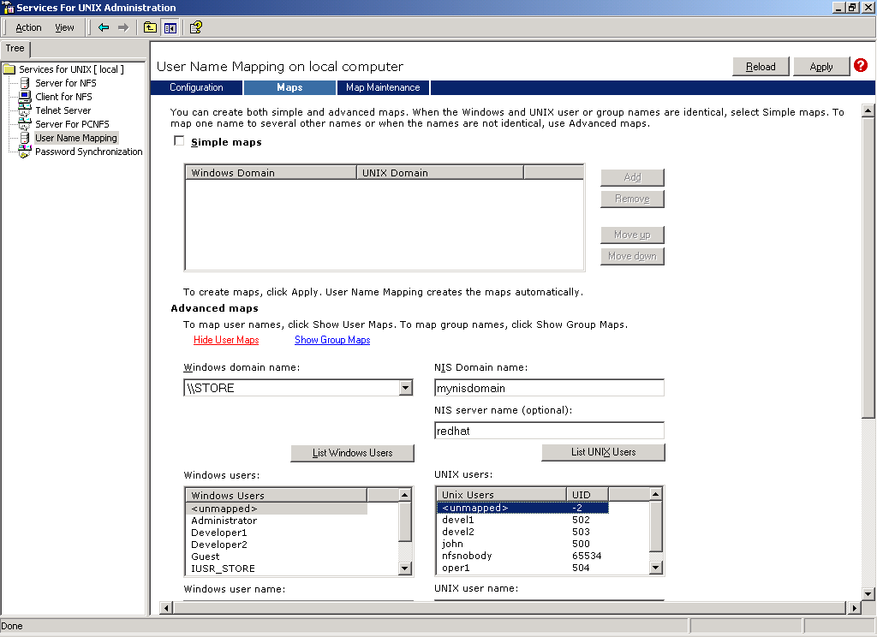
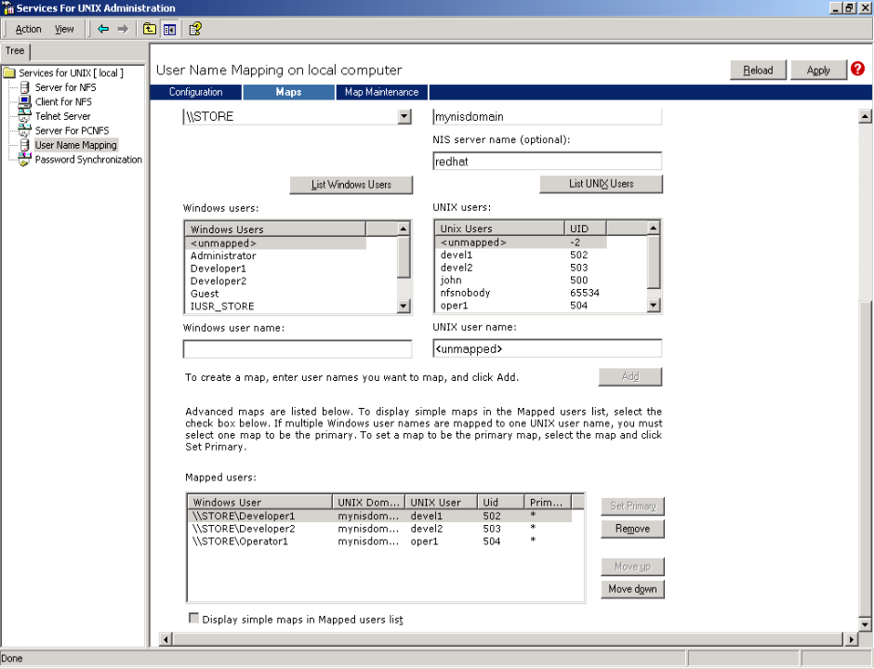

Figure 22. User Name Mapping between UNIX and Windows hosts. Listing users.

Figure 23. User Name Mapping between UNIX and Windows hosts. Mapping users with non-matching names.
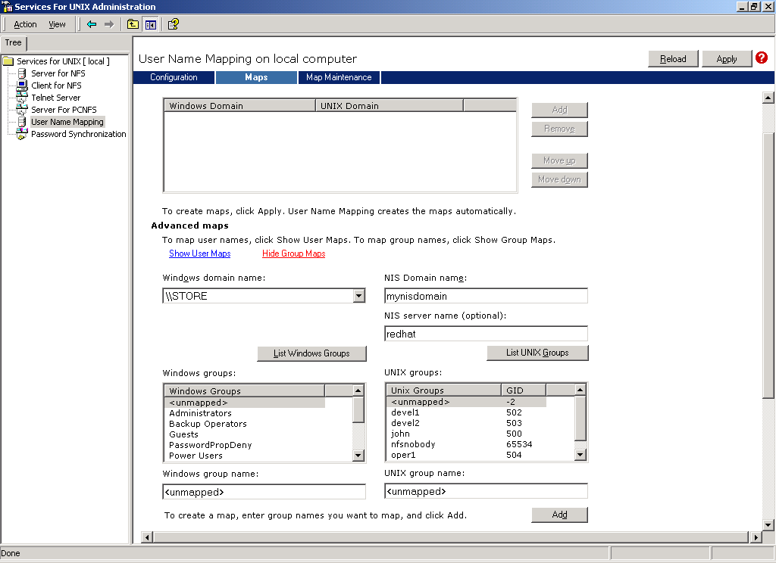

Figure 24. User Name Mapping between UNIX and Windows hosts. Mapping user groups.

Migration of NIS to Active Directory
Server for NIS integrates Windows Active Directory and NIS by giving a Windows-based Active Directory domain controller the ability to act as a master NIS server for UNIX NIS domains. Server for NIS stores NIS map data in Active Directory, and creates a single name space for the Windows and NIS domains that can be managed by the Windows administrator using a single set of tools. A user who has accounts on both Windows and UNIX systems can be managed from Active Directory with all attributes necessary for the respective domain and name space. All the changes in Active Directory are automatically propagated to the slave NIS servers.
After successful installation of the Server for NIS, NIS maps can be migrated to Windows using either the NIS Migration Wizard or a command-line utility (nis2ad). Server for NIS can import multiple NIS domains and either merge them or support them concurrently. Directory entries can be managed with standard Windows GUI tools such as Active Directory Users and Computers, or with command-line tools. Additionally, Active Directory Service Interfaces (ADSI) or LDAP interfaces can be created using standard Windows tools.
In order to migrate NIS to Active Directory, administrators have to take the following steps:
- Check that Server for NIS is installed and configured. If not, log on as a member of the Schema Admins group on an Active Directory domain controller and install Server for NIS on the domain controller.
- Check that the NIS server(s) on UNIX are running and accessible from the Windows server.
- Back up the Windows domain controller or run a migration process on a test domain controller.
- Run the Migration Wizard to go through all the steps to migrate the NIS maps to Active Directory.
- Examine migration logs for potential migration conflicts and handle them as needed.
- Migrate the NIS maps to a Windows domain controller with the command-line tool called nis2ad or with the Migration Wizard. Administrators must specify an Active Directory container that will hold NIS objects; otherwise, a default container will be used.
- Examine the post-migration log for errors and conflicts.
- Inform the existing subordinate (slave) NIS servers of the new master NIS server.
- Instruct the existing NIS clients to use the new master NIS server.
- Disable the original NIS server.
- Set the passwords on newly created accounts to default value, and securely inform the users.
Subordinate NIS servers based on UNIX can continue to work as before, but will receive map updates from the Windows domain controller rather than the UNIX-based computer. After the maps are migrated to the Active Directory, other UNIX-based subordinate (slave) servers can also be migrated to other domain controllers in the same Windows domain. Migration of subordinate servers does not require migration of the data. Because of the architecture of Active Directory, other domain controllers in the Windows domain share the same Active Directory schema and database. Consequently, these domain controllers already have the NIS data. After the Server for NIS is installed on a domain controller in the same Windows domain, it is ready to act as a subordinate NIS server for the NIS domain.
NOTES
If a new Windows user is created as a result of the migration, the user's Windows and UNIX passwords are set to a random value. Before the user can log onto the Windows domain or a UNIX computer in the NIS domain, an administrator must change the user's Windows password to a known, temporary value, inform the user what the temporary password is, and then set the account properties so that the user must change his password on the next logon. After the user logs in and changes the Windows password, the new password will be propagated to UNIX-based NIS clients the next time the NIS maps are refreshed. If migration results in adding UNIX attributes to an existing Windows user, the UNIX password in Active Directory will be set to be the same as the existing UNIX password, and the Windows password will remain unchanged.
Since the password is automatically propagated from Windows to UNIX unidirectionally, all password changes on the UNIX side will not affect Windows passwords, thus making Active Directory and NIS passwords differ. Users should be instructed to change passwords only in Windows to ensure that Windows and UNIX passwords in the NIS map are identical.
During migration, conflicts might occur between objects that already exist in Active Directory and objects with the same name that are being migrated. In such cases the objects being migrated are automatically renamed by Migration Wizard. This requires administrators to carefully examine migration logs to identify the way in which each discrepancy was handled. Alternatively, administrators could run the Migration Wizard in a mode where the wizard goes through all the steps required to migrate an NIS domain to Active Directory, records the anticipated migration results, but does not actually make changes to Active Directory.
To support file sharing across Windows and UNIX, MS SFU 3.5 supports Server for NFS and Client for NFS.

configuring nfs

Server for NFS
With Server for NFS, a Windows computer can act as a network file system (NFS) server. Users can then share files in a mixed environment of computers, operating systems, and networks. Users with computers running NFS client software can gain access to directories (called shares) on the NFS server by connecting (mounting) to those directories.
Server for NFS in SFU 3.5 has many improvements over the same in SFU 2.0. Some of these improvements are:
- The Server Settings tab in the Admin UI section gives the administration more configuration options like enabling TCP, setting directory cache size, setting authentication token expiration intervals, setting character translation filenames, and configuring case-sensitivity settings.
- Server for NFS is now cluster-enabled, which allows it to be deployed in environments where high availability is critical.
- Most performance-related settings are now dynamic. This allows administrators to tune the server based on usage patterns and traffic.
- The model for translating UNIX permission mode bits to and from Windows access control lists (ACL) has been revamped. The model is consistent with the Windows security model and also results in predictable permissions seen by UNIX client users.
- Visual indication of exported NFS shares in Windows Explorer.
- Support for wildcards in client group configuration.
- Support for exporting shares with filenames in East Asian character sets such as Japanese, Korean, and Chinese has been included.
NOTE: UNIX computers follow advisory locking for all lock requests. This means that the operating system does not enforce lock semantics on a file, and applications that check for the existence of locks can use these locks effectively. However, Server for NFS implements mandatory locks even for those locking requests that are received through NFS. This ensures that locks acquired through NFS are visible through the server message block (SMB) protocol and to applications accessing the files locally. Mandatory locks are enforced by the operating system.

Client for NFS
Client for NFS gives a Windows-based computer the ability to act as a client to a NFS server. With Client for NFS, Windows users can access files in a mixed environment of computers, operating systems, and networks as though it were any other shared drive on the network. Users can access shares on the NFS server by mounting those shares to their computer using either the “Tools->Map Network Drive” option in Explorer, or using the “mount server:/export” command-line or the Windows “net use \\server\share” command-line syntax. Shared folders can also be mounted by browsing the NFS LANs in the NFS Network folder located in My Network Places. Shares mounted on the NFS server are treated as though they reside on the client computer and the files contained therein are indistinguishable from files on the client computer.
Some of the improvements in Client for NFS in SFU 3.5 are:
- Support for creating symbolic links and ability to set setuid/setgid/sticky bits.
- Client side Directory caching results in much better performance.
- Ability to set file attributes from the Explorer Property page and also to see NFS mount options.
- Improved support for international character sets (Korean, Chinese, and Japanese).

Configuration of NFS Client-Server Environment in Windows
Perform the following steps:
- Make sure that Server for NFS is installed and started.
- Make sure that Client for NFS is installed.
- In Explorer, right-click on a directory (in our case, C:\SFU) and choose Sharing and then NFS Sharing.
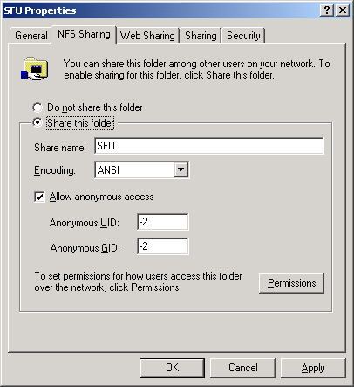
- Share the folder and allow anonymous access.

Figure 25. NFS folder sharing in Windows.
- Click Permissions to set and control the access rights of different computers or client groups. In this example we specify the loose security, but can tighten it if needed.
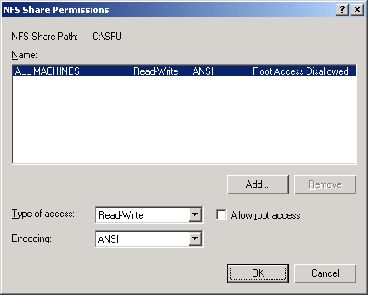
- In Explorer, right-click My Network Places and choose Map Network Drive.

Figure 26. Checking permissions in NFS folder sharing in Windows.
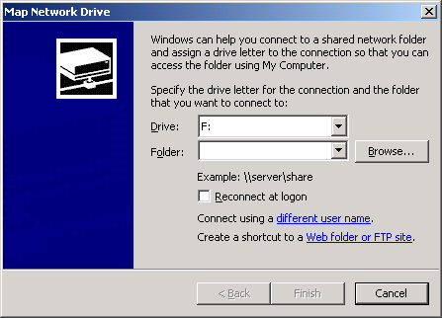

Figure 27. Mapping shared NFS drive in Windows.
- Click Browse to browse the NFS network.
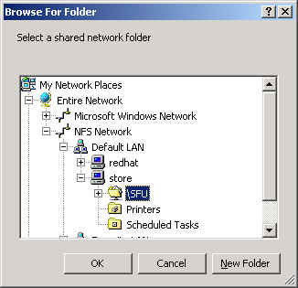
- Choose your computer and your share and map it.

Figure 28. Mapping shared NFS drive in Windows.
- Agree to accept the current login.
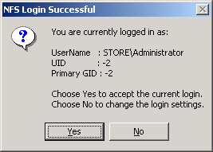
- Open Explorer to confirm that the drive was mapped successfully and you can browse its contents.

Figure 29. System prompt during NFS mapping process.
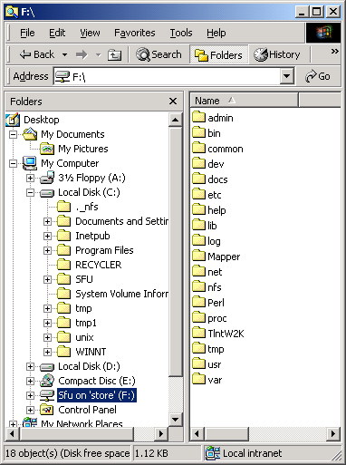
- We have just tested that NFS installation was correct on the Windows side.

Figure 30. Testing access to the data on the mapped NFS drive.

Configuration of NFS Client-Server Environment in UNIX
Perform the following steps:
- Make sure that NFS Server is installed on your UNIX environment. If not, download and install the appropriate packages.
- Create a directory (e.g., /soft), and populate it with a file.
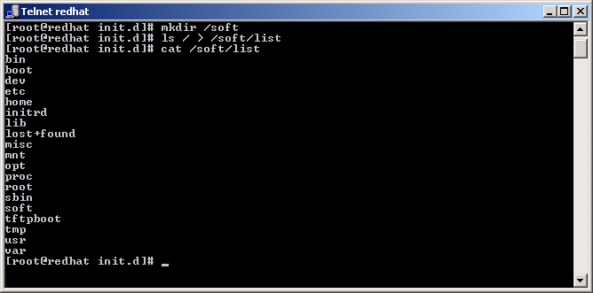
- Edit /etc/exports to allow localhost, eth0 IP of the UNIX computer, and IP address of the SFU computer.
- Start portmap, nfs, and nfslock daemons in the /etc/rc.d/init.d directory and make sure that they were started.

Figure 31. Creation of a directory in UNIX and creation of a file in the directory.
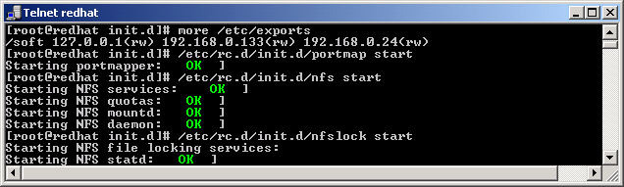

Figure 32. Starting NFS services on UNIX.
- Test that NFS services are running.
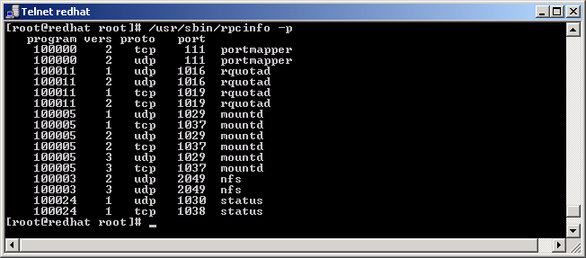
- Create a directory to mount NFS share to (e.g., /mnt/nfs).
- Mount local NFS share to /mnt/nfs.

Figure 33. Testing that NFS services are running.
- List /mnt/nfs and display the file to make sure that the share was mounted properly.
- We have just tested that the NFS installation was correct on the UNIX side.
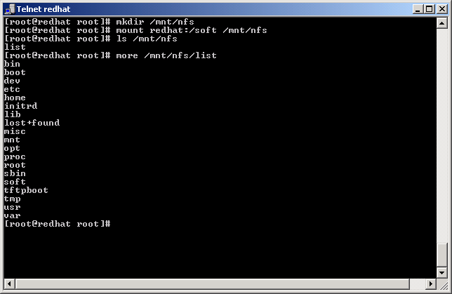

Figure 34. Mapping NFS share from UNIX and testing file access in the mapped share.

NFS Mapping Between Windows and UNIX
We will use the same procedures to map a share on UNIX NFS Server from Windows and to map a share on Windows NFS server from UNIX. Perform the following operations:
- In Explorer, right-click My Network Places and choose “Map Network Drive.”
- Click Browse to browse the NFS network.
- Choose your computer and your share and map it.
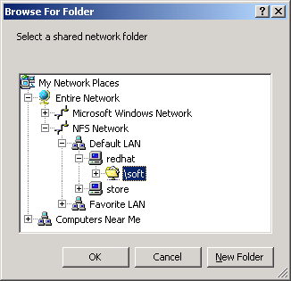

Figure 35. Mapping UNIX NFS share from Windows.
- Agree to accept the current login.

Figure 36. System prompt during NFS mapping process.
- The newly mapped drive appears in a separate window.
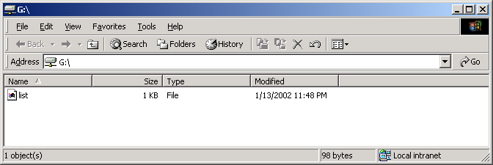

Figure 37. Listing the content of the mapped NFS share.
- List the content of “list” file to make sure that it is readable.
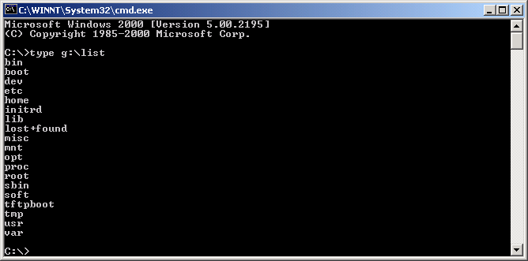

Figure 38. Checking the integrity of the file on the mapped NFS share.
- We have just successfully mapped a UNIX NFS share on Windows.
Let us perform the opposite operation. Please take the following steps:
- Unmount the previously used /mnt/nfs mount point.
- Check that the mount point was properly unmounted.
- Mount the Windows NFS share onto the /mnt/nfs mount point.
- List /mnt/nfs to see that the directory structure is identical to c:/SFU.
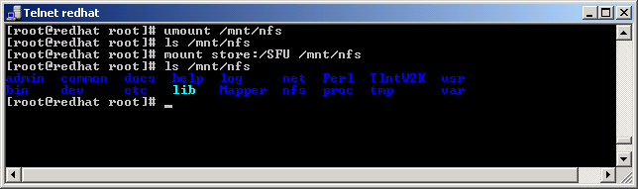
Password synchronization makes it easy for users to maintain one user name and password for Windows domains and UNIX systems by synchronizing the passwords between systems when one of them changes. Depending on how Password Synchronization and the UNIX servers are configured, synchronization can be one-way or two-way.

Figure 39. Mapping Windows NFS share from UNIX and testing its content.

configuring password synchronization
Password synchronization runs as an extension of the LSA service on the Windows side. On the UNIX side it is achieved by running a UNIX daemon called Single-sign-on-daemon (ssod). The Windows Password sync service and the SSOD UNIX daemon exchange encrypted password data. On the UNIX end, the password change is implemented via the pluggable authentication module (PAM).
The following UNIX variants are supported by synchronization services:
- Hewlett-Packard HP-UX version 11
- Red Hat LINUX version 6.2 and up
- Sun Microsystems Solaris version 7
- IBM AIX version 4.3.3
The present section will describe the installation and configuration of password synchronization.

On the Windows side:
- Create two users: peter (with password demo1!) and john (demo2@).
- Make sure that the UNIX host is entered in c:\WINDOWS\system32\drivers\etc\hosts file.
- Start Services for UNIX Administration and configure password synchronization options and advanced options as displayed. In our case the key AbCdEfGh12345 was chosen.
- You will need to check the direction boxes to make the 2-way synchronization happen.
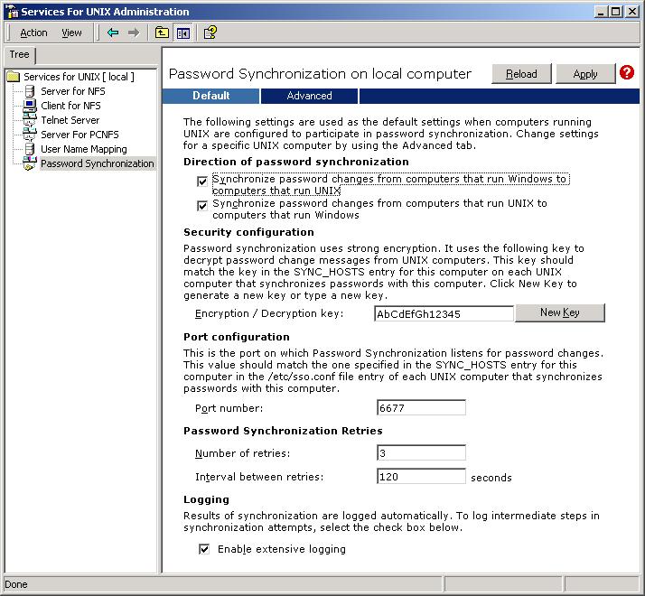
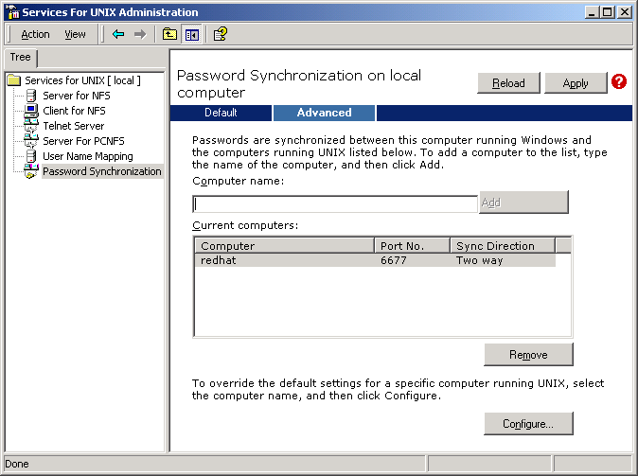

Figure 40. Configuration of password synchronization services.

Figure 41. Configuration of targets and ports in password synchronization services.
- Click Apply.

On UNIX side (RedHat 8.0 was taken as an example):
- Log in as root.
- Execute the following commands from UNIX console:
  - “Useradd peter”
  - “Useradd john”
  - “Passwd peter (set as 123)”
  - “Passwd john (set as 456)”
- Make sure that port 6677 is enabled by the firewall.
- Make sure that your Windows servername is entered in /etc/hosts.
- Mount the SFU CD and copy the files or FTP the files over in binary mode. The files needed for RedHat are pam_sso.l52, sso.cfg, and ssod.l52.
- Execute the following commands from UNIX console:
  - “cp ssod.l52 /usr/bin/ssod”
  - “chmod +x /usr/bin/ssod”
  - “cp sso.cfg /etc/sso.conf”
- Edit sso.conf to specify the following:
  - “ENCRYPT_KEY=AbCdEfGh12345”
  - “PORT_NUMBER=6677”
  - “SYNC_HOSTS=(domainController[, portNumber [, encryptionKey]])” or in our case “SYNC_HOSTS=(store, 6677, AbCdEfGh12345)”
  - “USE_NIS=0”
  - “USE_SHADOW=1” (if applicable)
- Execute the following commands from UNIX console:
  - “cp pam_sso.l52 /lib/security/pam_sso.so.1”
- Edit file /etc/pam.d/system-auth with a text editor, and locate the following line:
  - password required /lib/security/pam_cracklib.so retry=3
- After the line in the previous step, add the following line:
  - “password required /lib/security/pam_sso.so.1”
- Locate and delete the following line:
  - password required /lib/security/pam_deny.so
- Execute the following commands from UNIX console:
  - “cp /etc/pam.d/passwd /etc/pam.d/ssod”
  - “/usr/bin/ssod”
Now try changing peter’s and john’s passwords on Windows and see them changed on the UNIX side. Establish a telnet session to your UNIX computer and log in as peter and john to verify the password change. Perform password changes on the UNIX side to see them changed on the Windows workstation. To do this you can log in locally on the Windows workstation as peter or john.
In the contemporary enterprise computing paradigm, cross-platform interoperability is necessary in a heterogeneous environment. Relative to this need, Microsoft Windows Services for UNIX 3.5 tells a very compelling story. SFU 3.5 is a mature solution that significantly expands on the cross-platform interoperability tools offered in prior versions of the product. The SFU 3.5 offering shows substantial increases in support for running UNIX programs and scripts natively on the Windows Server 2003 Family, Windows XP Professional and the Windows 2000 Family of operating systems. Specifically, the Windows-based Interix subsystem allows UNIX or Linux systems administrators and developers to run legacy shell scripts (as well as command line and X11 applications) on Windows with little or no modification. Furthermore, scripts that have been migrated to Interix execute at significantly higher levels of performance than can be achieved through UNIX-like emulation products.

conclusion
IT shops have the ability to create a single solution that operates natively across of the Windows, UNIX or Linux servers that run on their network. Companies looking for a well-rounded, solid interoperability solution will be hard pressed to find (or develop) a Windows/UNIX interoperability toolkit comparable to Microsoft Windows Services for UNIX 3.5.

New Feature Comparison with different Versions of SFU

appendix A
Feature | Description
NFS Client | Supports sticky/setuid/setgid bits
 | Support for symbolic links
 | Performance improvements
 | Internationalization: additional language options
NFS Server | Significant performance enhancements
 | Support for active-active clustering of Network File System (NFS) shares
 | Support for setuid, setgid, sticky bits
 | Per-share handing of root and anonymous access
 | Improved model for mapping permissions between Windows and UNIX
 | Internationalization improvements
SFU3.5 | Support for Windows Server 2003 Volume Shadow Copies
SFU3.5 | Simplified and enhanced authentication in Windows Server 2003 Active Directory environments
NFS Gateway | Internationalization improvements
Mapping Server | Cluster-enabled mapping server
 | Performance, security and scalability improvements
 | Support for redundant mapping servers
 | Internationalization improvements
Server for NIS | Support for MD5 encryption
 | Scalability and performance improvements
 | Numerous usability and administration improvements
Password Sync | New support for setting passwords using Pluggable Authentication Model on UNIX.
Telnet Server | Security and scalability improvements
 | IPv6 support
 | Dumb terminal support (handhelds)
Telnet Client | IPv6 support
 | Internationalization
Interix and the Interix SDK | New in SFU 3.0.
 | Improved throughput and stability
 | Single rooted filesystem
SFU3.5 | Utility updates for Internationalization
SFU3.5 | pthread support in SDK
SFU3.5 | API support for Internationalization

appendix B
##########################################################################
# Shellscript: allfiles - apply command to all files in all subdirectories
# Author : Heiner Steven (heiner.steven@odn.de)
# DAte : 19.04.94
# Category : File Utilities
# $Id: allfiles,v 1.2 2000/02/06 19:55:35 heiner Exp $
##########################################################################
# Beschreibung:
#
##########################################################################

PN=`basename "$0"` # Program name
VER=`echo '$Revision: 1.2 $' | cut -d' ' -f2`

Usage () {
echo "$PN - apply command to all files in all subdirectories, $VER
usage: $PN command [arg ...]

The given command will be applied to all files in the current
and in all subdirectories -- USE WITH CARE." >&2
exit 1
}

[ $# -lt 1 ] && Usage

find * -type f -print | xargs "$@"
:

appendix c
# rmemptydir - remove empty directories
# Heiner Steven (heiner.steven@odn.de), 2000-07-17
#
# Category: File Utilities

[ $# -lt 1 ] && set -- .

find "$@" -type d -depth -print |
while read dir
do
[ `ls "$dir" | wc -l` -lt 1 ] || continue
echo >&2 "$0: removing empty directory: $dir"
rmdir "$dir" || exit $?
done
exit 0

